Download the pattern from Shanniemakes.com. You will need the Cover Mask pattern. The pattern will give 2 filter lining options.
- Seam Allowance is 1cm or 0.4inches, 3/8inch unless stated.
- Edge stitching is stitching close to the edge/folded edge. Usually 1-2mm (0.07inches, 5/64 inch) away from the edge.
- Filter Lining (Also known as the Filter Slot/Filter Lining Slot).
You have the option to shorten the left edge on the Filter Lining pattern.  By shortening it, you will make it wider to allow the easy insertion of a filter. | 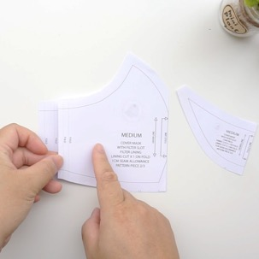
Cut off anything from 1-4cm/0.4-1.57inches is sufficient amount.  Don't forget you will lose another 1cm/0.4inches at the end when making the edges neat. | 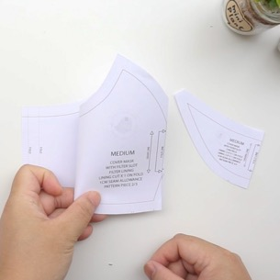
Cut out the fabric pieces required:  Main fabric cut x1 on Fold  Lining cut x1 on Fold  Filter Lining x1 on Fold  Fold all fabrics with the right side on the inside. Only have the fabric facing out to check on the print placement.  Make sure the fabric is folded on grain. What this means is the raw edge and the folded edge is parallel (Equal distance away from each other). | 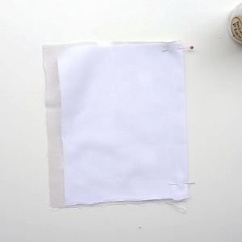
Be aware of your fabric print. You may need to cut it on the weft grain. Making sure the folded edge and the raw edges are parallel.  Check your pattern is on grain by using a ruler and measuring it against the folded or the raw edge and comparing it to both ends of the grainline on the pattern.  Pin the pattern pieces onto the fabric, right against the folded edge. | 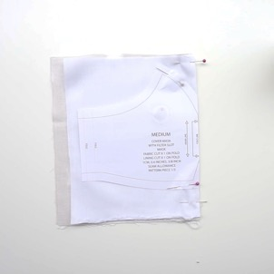
By stacking the Main mask fabric on top of the Lining fabric, making sure the folded edge is aligned, you can cut both layers together.  Cut out required fabric pieces. | 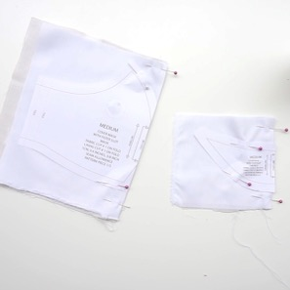
Please note: These fold markings on the side are only guides, you do not have to notch or fold this edge over exactly as illustrated.  Next you will need to snip the notches at the edge of the pattern. This will help you fold the darts as well as putting the pattern together.  Make sure these are only small snips. | 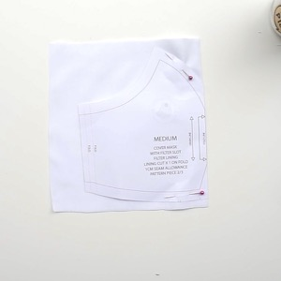
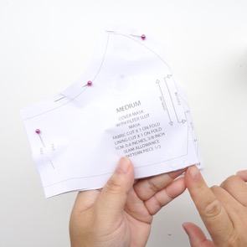 | 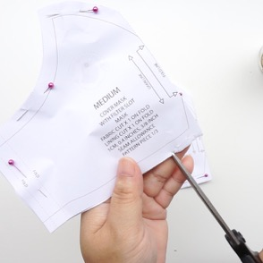
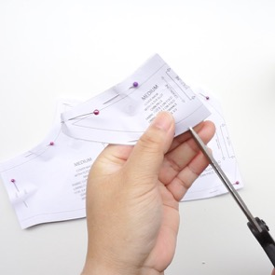 | 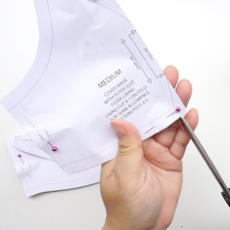
Cut and prepare your elastic by cutting it to length and tying the ends together. Do this to bother pieces.
Seal the ends with a flame.

Cut the nose bar to size if you are using any. Prepare it like this for easy insertion. | 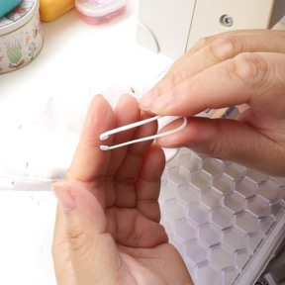
For the Main mask fabric and Lining fabric, which is cut together, you will need to mark the same points on both fabric pieces.  You can mark this point with a piece of chalk or pencil. Otherwise use the pin method. I find this much easier.  Put a pin in through both layers. | 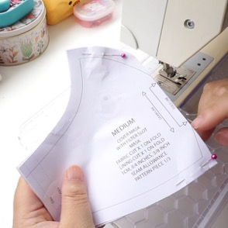
Either mark or put a pin in through both layers at this point too.  Put a pin in through both layers. | 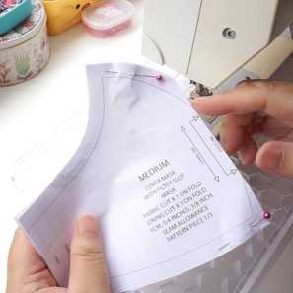
Now repeat the pinning process on the other side of the fabric.  In totally you should have 2 pins going in one way and 2 pins going through the other side like the picture below.  Separate the fabric pieces. It should look like the picture on the bottom left. | 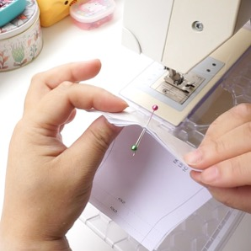
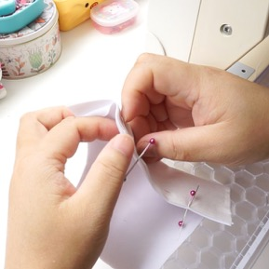 | 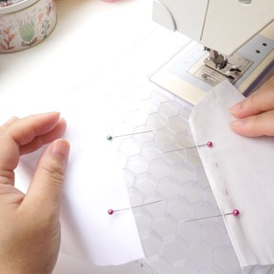
Main mask fabric, on the wrong side of the fabric, we are going to sew the seam/dart. From this top point to the edge using 1cm/0.4inch seam allowance.  When sewing, you must remember to back stitch at the beginning and end of your sewing. I will not be prompting you to do this. Back stitching is vital to ensure your stitches does not come undone.  Make sure your seam allowance is even and accurate. | 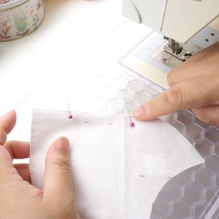
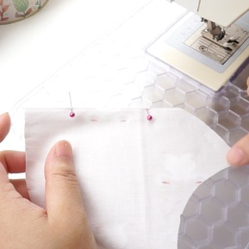 | 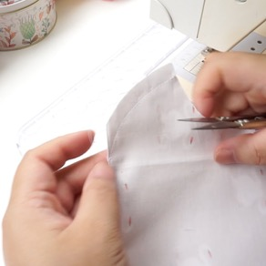
Next we are going to sew the bottom dart.  Sew from the point to the notch closest to the folded edge. Here I am showing you on the paper pattern as well as the fabric piece. | 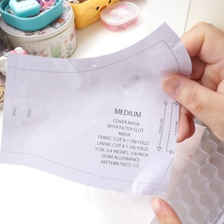
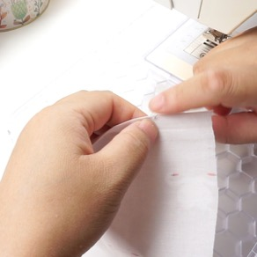 | 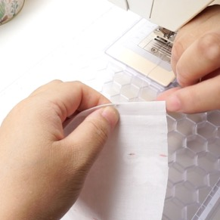
Repeat the same process with the Lining. | 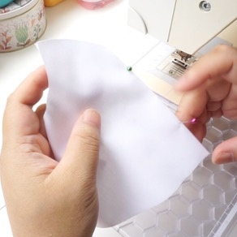
Sew the top and bottom seam/dart in the same way. | 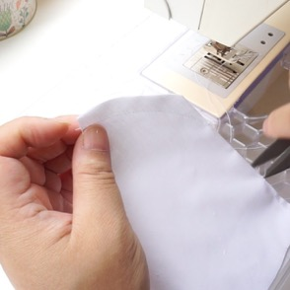
Next we will be sewing the Filter Lining. I will use the paper pattern to show you what needs pinning or marking to make it clearer for you.

Mark the top point just like previously, but you will only need to use one pin here because it is only one piece of fabric.

You will also need to pin here at the bottom dart.  Remember to place a pin (Picture below) to remind you to leave a 1cm/0.4inch gap for the nose bar slot. | 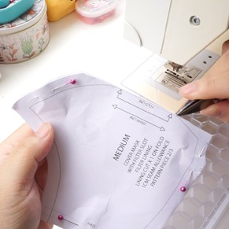
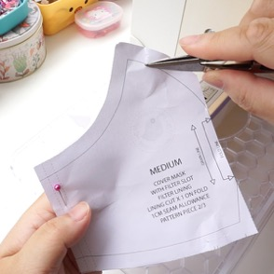 | 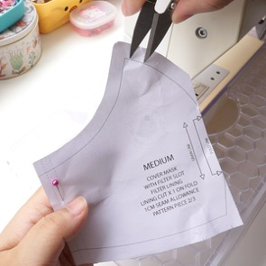
On the wrong side of the fabric, start sewing from the point at the centre front fold line to the top edge. Remember to leave the gap.  You must back stitch in this area before finishing the dart to ensure it does not become undone later.  Sew the bottom dart. | 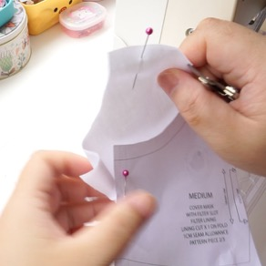
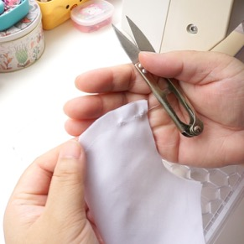 | 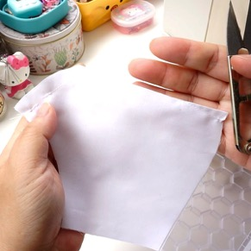
Open the Filter Lining up. On the side edges, with the wrong side facing up, fold over 5mm/0.19inches, then another 5mm/0.19inches.  Edge stitch this on the sewing machine.  Repeat on the other edge. | 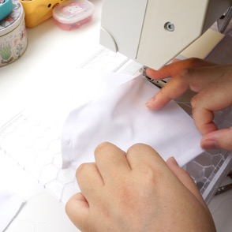
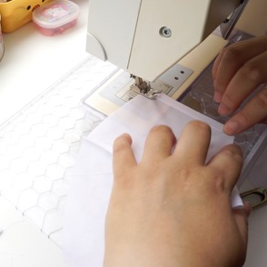 | 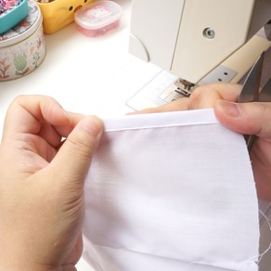
Time to notch the curved edges. This will ensure the seams will lie open and flat when pressed.  When snipping the Filter Lining, don’t cut too close to the gap. Snip along towards the tip, but not in this gap.  Snip along the seam using diagonal cuts. Careful not to cut into the stitch line. | 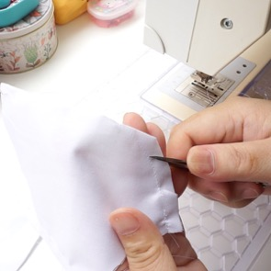
On the final cut, closest to the point, cut close to the stitch line. This will allow the point to lie flat on either side of the mask when ironed. | 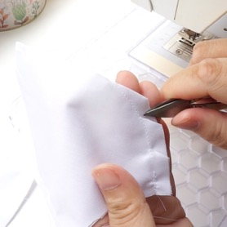
Go back and cut the other direction to snip out V notches until you have several roughly 1cm/0.4inches apart. | 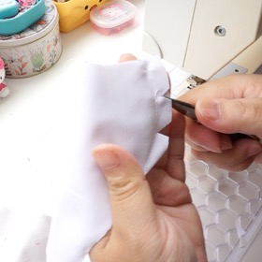
As demonstrated here, the end lies in either side of the mask. | 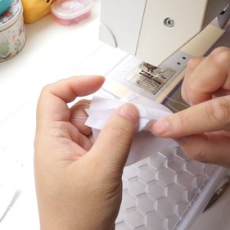
Now either cut/snip/grade/notch all the curved darts/seams on the Main and Lining fabric pieces.  This is optional: Open the seams and run your thumbnail over the seam to break the grain. This will help hold the seams apart ready for pressing. Do this to all 3 fabric pieces. | 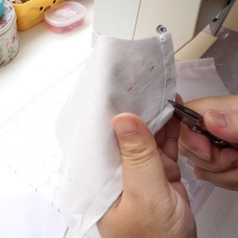
Time to sew the Chin Piece.  Open the fabric out. Placing the right sides touching the right sides.  You are going to sew the top edge. | 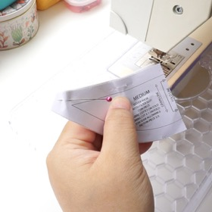
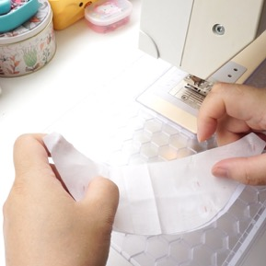
Now either cut/snip/grade/notch the curved seam on the just sewn top edge.  Snip in one direction. | 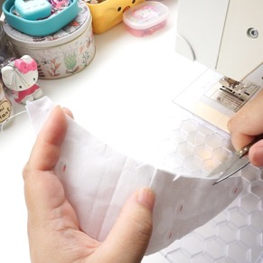
Then snip the other direction will make your work a lot easier.  Snip until you have cut out V notches about 1cm/0.4inches intervals along this edge. This will help the fabric to fold over. | 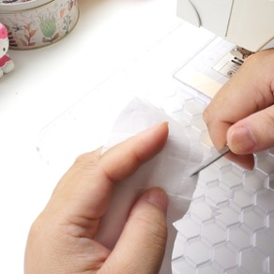
Open the fabric out. | 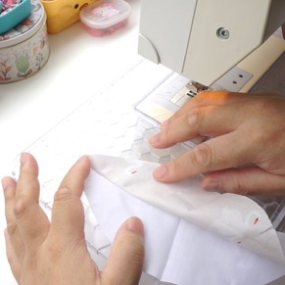
Make sure the seam allowance is on the left side, under the Lining fabric. | 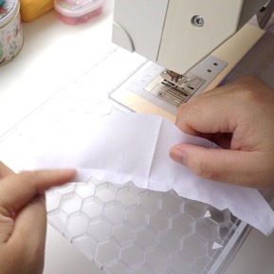
You are going to edge stitch on the Lining side, really close to the seam line. | 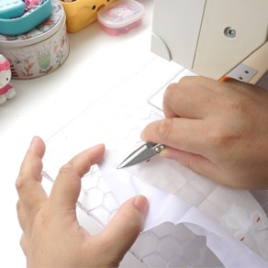
Hold the fabrics apart when sewing. This will help stop any fabric being caught underneath.
The edge stitch should look like this. | 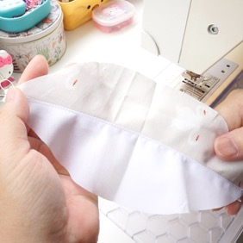
Fold it back into shape.  You should roll it so that you see a tiny bit of the Main fabric showing on the edge. | 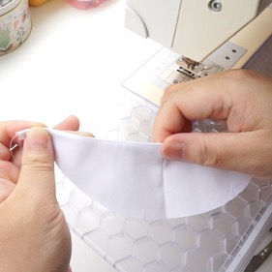
Fold it in half. | 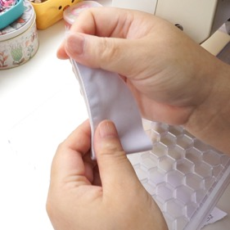
On the bottom right corner……… | 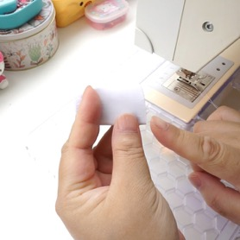
Make a little snip diagonally. Otherwise this could be a small notch. It is much easier to see when it is cut at an angle. | 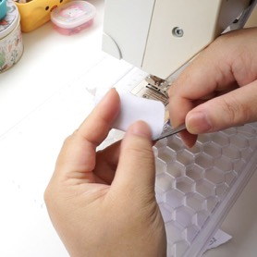
When you open it back up you should see a small triangle cut out. | 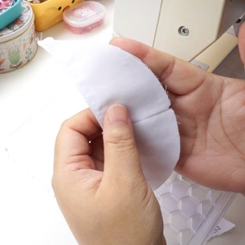
Time to assemble the mask.  Main fabric layer with right side facing up. | 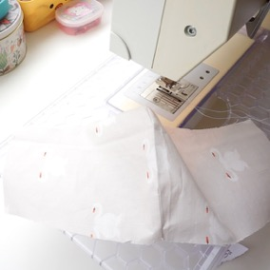
Chin Piece with wrong side facing up. Looks like a smile.  Filter Lining wrong side facing up. Matching the notch and seam lines in the centre at the bottom edge.  Lining layer with wrong side facing up. Match up the seam at the bottom edge. | 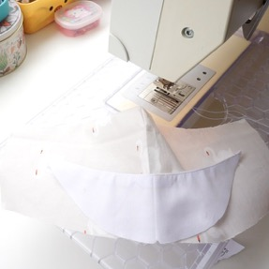
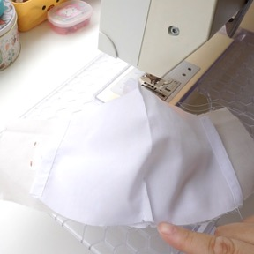 | 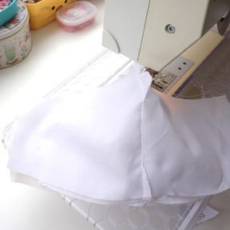
When pinning, make sure the darts do not all lie in the same direction to eliminate bulk.  Put the pin in roughly 1cm/0.4inches away from the edge before securing it. That is the seam allowance and by doing this, all seams will align up in the centre. | 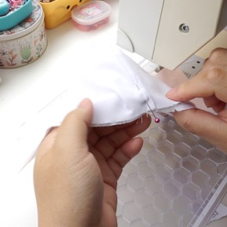
Work your way out from the centre. Pinning lay by layer as you go. This bit is the most time-consuming bit. Take your time.  Some people will baste this. Do this if you find it easier.  Once you have completed one direction, go back and work the other way out.  I usually pin both edges before sewing, but because this edge is tricky, it is best to sew it as soon as possible before tackling the other edge. | 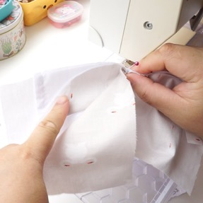
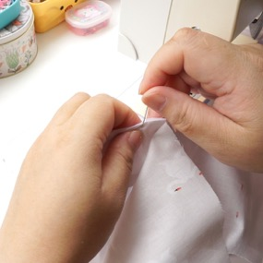 | 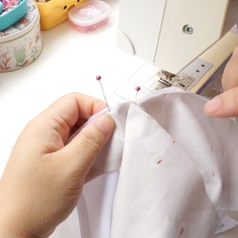
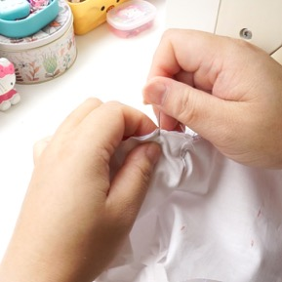 | 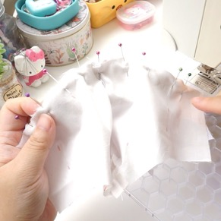
After you have sewn the edge, either cut/snip/grade/notch the edge. | 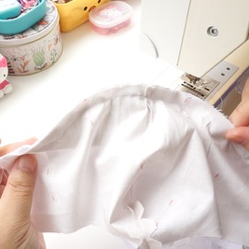
Snip out V notches at roughly 1cm/0.4inch intervals. Especially paying special attention the curved edges. It will make turning over and making the mask lie flat a breeze. | 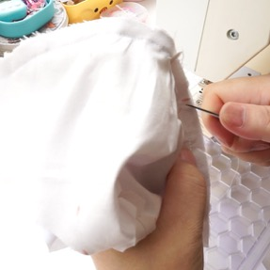
Turn to the other edge of the mask and start pinning from the centre out. Same process as the other side but without the curved Chin Piece.  Sew, then either cut/snip/grade/notch along the edge. | 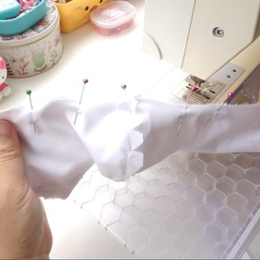
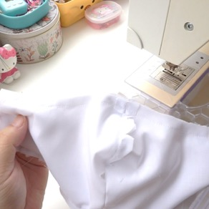 | 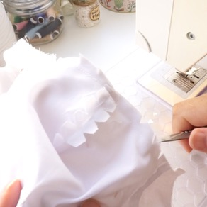
Turn the mask the right way out.  Choose the section between the Main fabric and the short Filter Lining.  Press with an iron.  Make sure no seams are tucked in on the edge. Use a pin, needle or clickers awl to pull out any hidden fabric in the edges. This is usually along the curved edges of the mask. | 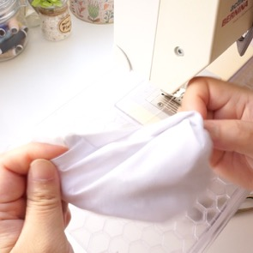
Lay the mask like this.  Prepare the elastic now if you haven't already done so. Otherwise you can do this at the end if you have a tool to thread the elastic.  Place one edge of the elastic loop on the edge of the mask. Fold over around 5mm/0.19 inches.  Then 1cm/0.4inches trapping the elastic inside.  Accuracy is not important here. | 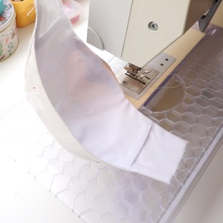
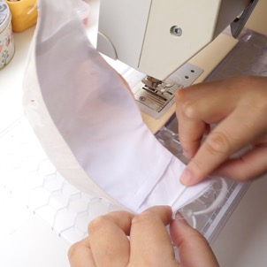 | 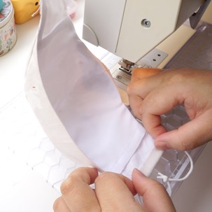
I usually just make the 2nd fold sit next to the Filter Lining if I used full width of the pattern.  If you made adjustments to the Filter Lining to make it short for easy access, then just use the folding measurements I gave you. Accuracy is not important if you are out by a few millimetres. | 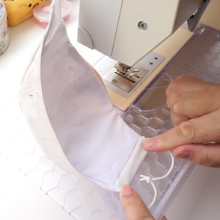
Edge stitch this in place.  Careful not to sew over the elastic.  Repeat the elastic process on the other edge. | 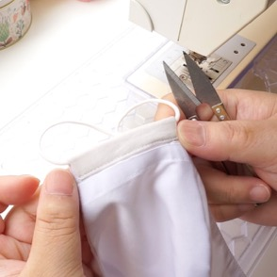
Carefully pull the elastic ends into the channel. Try not to stretch it.
Repeat on the other edge.

Edge stitch very close to the top and bottom edges of the mask. This will help reinforce it and helps with the structure.

Use a pin/needle/clickers awl to help ease out any fabric tucked inside on the seam edges. You can ease as you sew if it helps.
Avoid sewing over the elastic on the edges.

 | 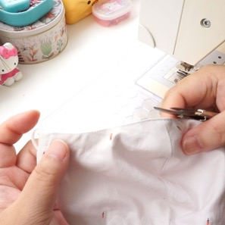
It is optional to edge stitch at the bottom edge.

Bottom edge is edge stitched. | 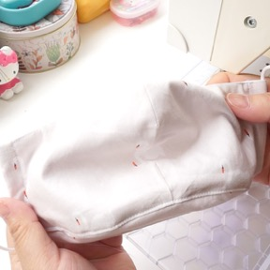
Prepare the wire now if you haven't already done so. This is optional.  If the wire scratches, bend the ends of both sides of the wire inwards.  Then bend the wire again in the centre, inwards. | 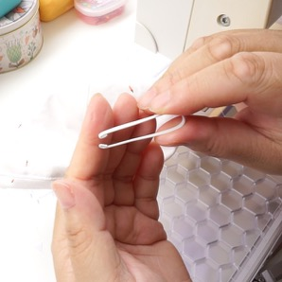
Fold the mask backwards so that the inside is only exposed.  If you done this accurately you should have a 1cm/0.4inch gap to slot your wire in later. (The 1cm/0.4inch gap we left on the Lining earlier) | 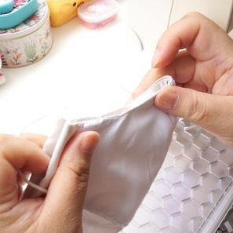
Put the bent nose wire against the top of the mask.  Matching the bend on the wire with the centre top of the mask. | 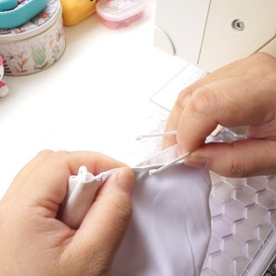
Put 2 pins on either side of the mask where the ends of the wire reach. This can be slightly more.  I like to sew the nose bar channel with the right side of the mask facing up, so that I can see my stitching on the right side.  You may sew on the wrong side up just to keep an eye out for the gap. | 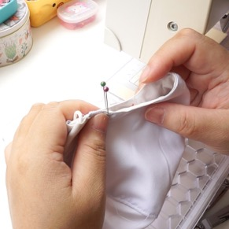
Starting on the left edge of the mask, sew roughly 4-5 stitches downwards. This should be roughly 1cm/0.4inches deep to accommodate for the gap.
Pivot the mask 90 degrees, and using the right edge of the mask as a guide, sew to the next pin.
When you reach the next pin, stop. Pivot 90 degrees again and complete the stitching.

The stitching should look like the picture below.
Fold the mask backwards with wrong side out, slide in the nose wire by slotting both ends into the left and right side of the nose bar channel.
Push in the remaining wire.
If you haven’t already inserted your elastic, do it now.
Complete!

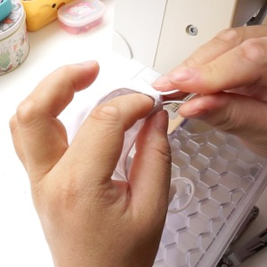 | 