Download the pattern from Shanniemakes.com. You will need the Cupped Mask pattern. The pattern will give 2 filter lining options. I only have instructions for the Conventional Filter Lining. If you want to make the mask using the Reverse Filter Lining, then I will suggest you to watch or look up the Reverse Filter Lining on the Basic 1 Piece Mask or the Cover Mask.
The steps are similar. Just make sure you place the 2 patterns (Filter Lining pattern on top of the Main pattern) and notch it in the same place through all layers, so that the pieces will fit back together. This step is shown in the instructions.
- Seam Allowance is 1cm or 0.4inches, 3/8inch unless stated.
- Edge stitching is stitching close to the edge/folded edge. Usually 1-2mm (0.07 inches, 5/64 inch) away from the edge.
- Filter Lining (Also known as the Filter Slot/Filter Lining Slot/Filter Slot Lining).

You have the option to shorten the left edge on the Filter Lining pattern. (Please note: for this particular pattern, it is simply called the LINING on the paper pattern. When I mention the Filter Lining, I am referring to this pattern, the smaller pattern. Sorry for any confusion caused. I will remind you.)  By shortening it, you will make it wider to allow the easy insertion of a filter.  I find my 4 fingers fit it loosely in this mask so there really isn’t any need to do this, but you have the choice to do this. | 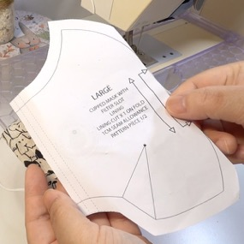
If you do decide to shorten it, then do the following:  Cut off anything from 1-2cm/0.4-0.78inches is sufficient amount.  Don't forget you will lose another 1cm/0.4inches at the end when making the edges neat. | 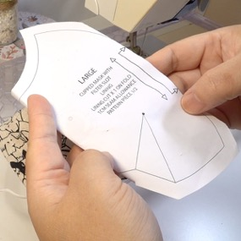
If you do decide to make the mask using the Reverse Filter option, then the pattern should look like this. There will be a line to tell you where to cut. | 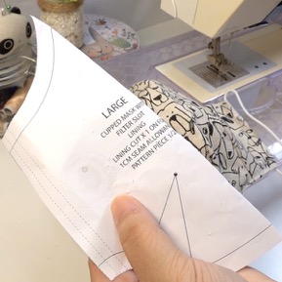
Cut out the fabric pieces required:  Main fabric cut x1 on Fold  Lining cut x1 on Fold  Filter Lining (smallest piece) x1 on Fold  Fold all fabrics with the right side on the inside. Only have the fabric facing out to check on the print placement.  Make sure the fabric is folded on grain. What this means is the raw edge and the folded edge is parallel (Equal distance away from each other). | 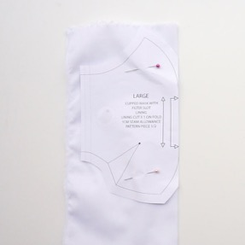
Be aware of your fabric print. You may need to cut it on the weft grain. Making sure the folded edge and the raw edges are parallel.  Check your pattern is on grain by using a ruler and measuring it against the folded or the raw edge and comparing it to both ends of the grainline on the pattern.  Pin the pattern pieces onto the fabric, right against the folded edge. | 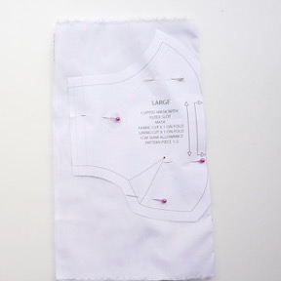
By stacking the Main mask fabric on top of the Lining fabric, making sure the folded edge is aligned, you can cut both layers together.  Cut out required fabric pieces.  The bigger pattern has 2 pieces of fabric cut.  The smaller pattern has 1 piece of fabric cut.  Please note: These fold markings on the side are only guides, you do not have to notch or fold this edge over exactly as illustrated. | 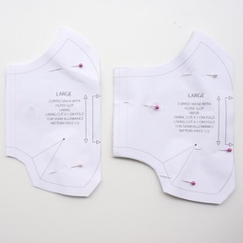
Next you will need to snip the notches at the edge of the pattern. This will help you fold the darts as well as putting the pattern together. | Make sure these are only small snips.  There are darts on each paper pattern.  Each pattern needs 2 snips on the edges.
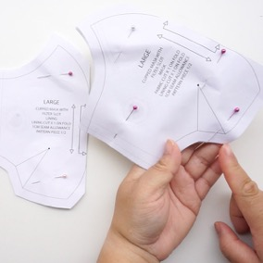 | 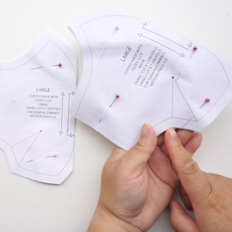
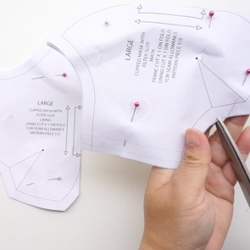 | 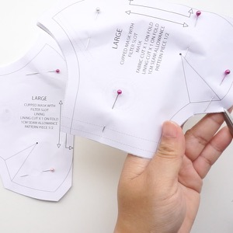
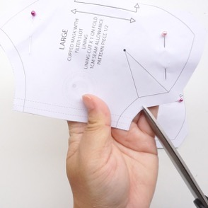 | 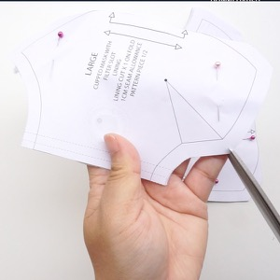
Next you will need to put in the markings for the darts and seams. You can use tailors chalk or a pencil to do this, but I prefer to use pins.  On the Filter Lining pattern (smaller pattern), put a pin in the tip of the dart. | 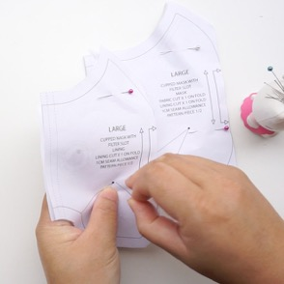
Turn it over and place a pin in through the same hole where the last pin is poking through. | 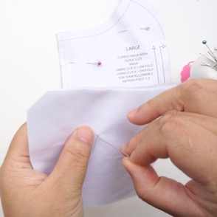
For a clearer picture, marks are indicated in red.  Put a pin into the point at the bottom of the pattern. The pin should be pinned onto the fabric.  Put a pin into the point at the top of the pattern. The pin should be pinned onto the fabric.  Carefully remove the paper pattern. A pin should come off with it. Put a pin back into the dart on the fabric. | 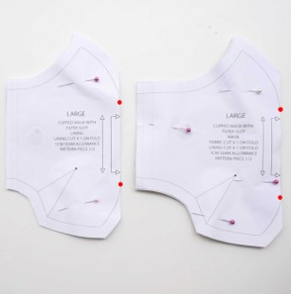
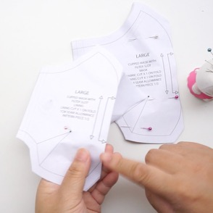 | 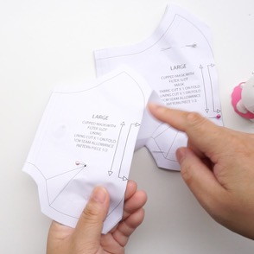
Open this Filter Lining fabric piece up.  You should have 4 pins. 2 in the centre and 2 either side. | 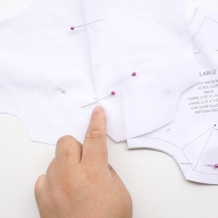
Now repeat this pinning process with the remaining fabric pieces.  We will deal with the Main Mask pattern. Be aware, this pattern piece is made of 2 pieces of fabric. We will need to do extra pinning to achieve the same markings as the Filter Lining pattern above.  First put a pin into the tip of the dart. | 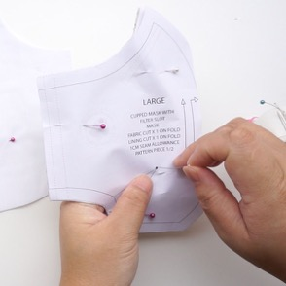
Turn it over and place a pin in through the same hole where the last pin is poking through. | 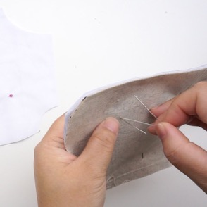
Put a pin into the fabric at the bottom dart/seam. Indicated with a red dot. Put it through one layer of fabric. (The process is repeating the steps above. You can check the picture above for a clearer view. This is indicated with the red writing next to it) Put a pin into the same point, but on the fabric underneath.  Put a pin into the fabric at the top dart/seam. Put a pin into the same point, but into the fabric underneath. | 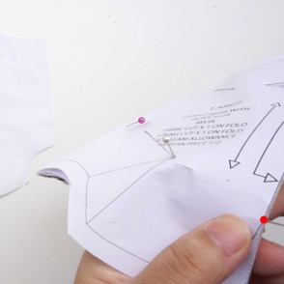
As you can see the purple pin and the pink pin are in the same position but on different layers of fabric.  Removed the paper pattern carefully and separate the 2 fabric pieces.  Some pins will come off with one fabric and not the other. This is normal. | 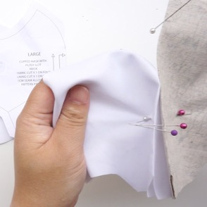
Just replace any pins in areas it has come off when separating. | 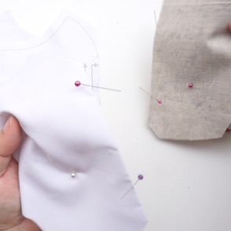
For example, mainly in the dart area | 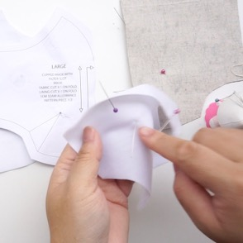
You can tell because you will see a pin poking through. | 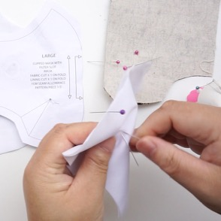
In total you should have 3 fabric pieces, and each with 4 pins on it. | 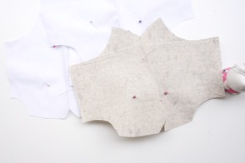
I will not be reminding you to back stitch at the beginning and end of your stitching. This should be second nature. If you don’t back stitch, your sewing will come undone over time.  Main fabric, with the wrong side of the fabric on the outside, sew the curved dart/seam at the top.  Make sure your seam allowance is even and accurate. | 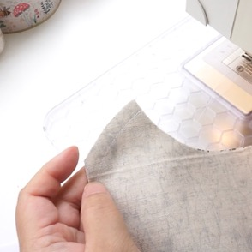
On the side of the fabric, pick up one layer of fabric.  With left hand, pinch at the tip of the dart. This is where the pin is. Fold this edge flat.  Put this tip into the sewing machine. Lower the needle into this point, but do not lower the presser foot yet. | 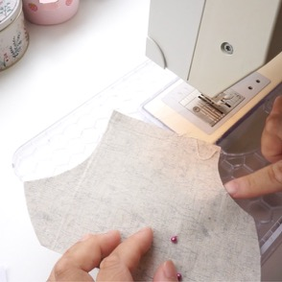
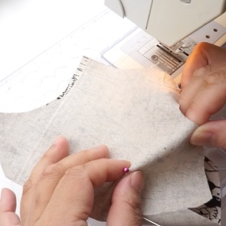 | 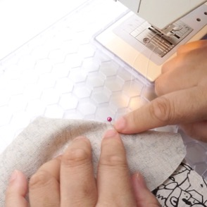
With the fabric in the sewing machine and the needle holding the fabric still, match up the 2 notches on the edge. This should be aligned if not on top of each other.
You may now lower the presser foot.
Sew to the edge.
Your dart should look like the picture.
Repeat this process to the other edge. | 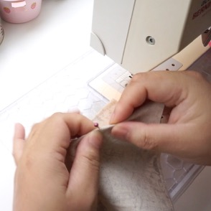
Finally complete the dart/seam at the bottom of the mask. | 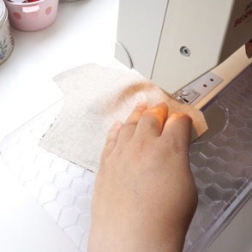
Repeat the same dart/seam process on the other 2 fabric pieces (Lining and Filter Lining) indicated with the GREEN text, but the top dart/seam is done differently on the Filter Lining. The smaller pattern.  You must leave a gap! | 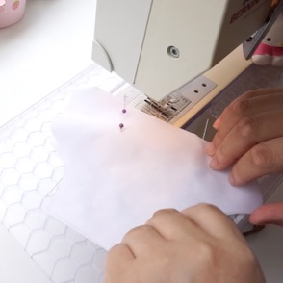
Sew this dart/seam as normal, but leave a gap as indicated on the pattern.  Back stitching is very important to ensure the stitching does not come undone.  This gap is 1cm/0.4inches wide for the nose bar slot.  Complete the remaining seam allowance. | 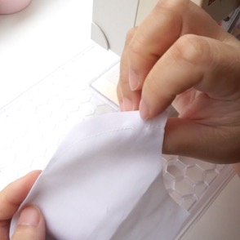
Time to notch/cut/grade/snip the curved edges, mainly the top and bottom dart/seam on all 3 fabric pieces. This will ensure the seams will lie open and flat when pressed.  Snip along the seam using diagonal cuts. Careful not to cut into the stitch line.  The bottom dart/seam only requires 1 notch.  When cutting the V out, make the middle deeper with a cut close to the stitch line. | 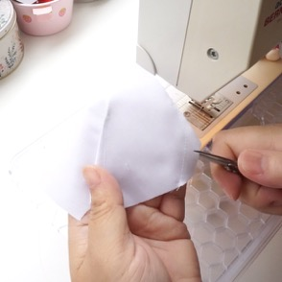
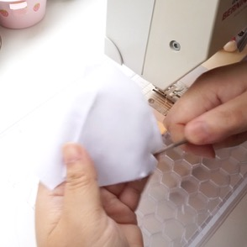 | 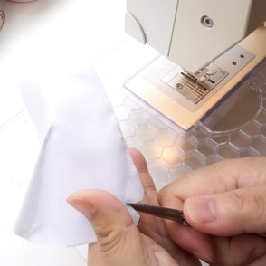
The cut should look like this. | 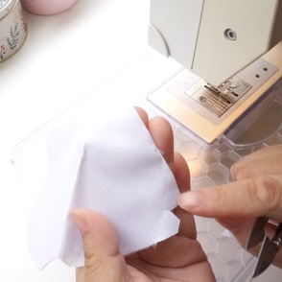
When notching/cutting/grading/snipping the top curved dart/seam on all 3 fabric pieces, make the V cuts about 1cm/0.4inches apart. | 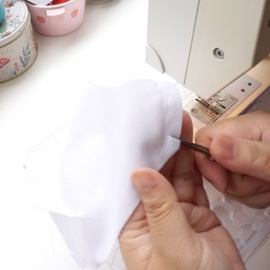
When snipping the Filter Lining, don’t need to cut in the gap.  The notch that is closest to the tip, snip the centre slightly closer to the stitch line. | 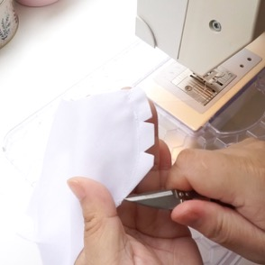
This will allow the tip to lie on either side of the mask when ironed. | 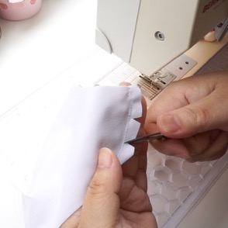
Repeat the notching/cutting/grading/snipping process on the Lining piece. | 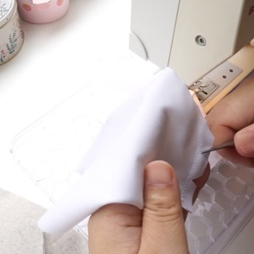
Repeat the notching/cutting/grading/snipping process on the Main fabric piece. | 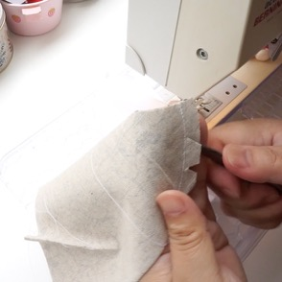
On the Filter Lining, wrong side facing up.

On the edges fold over 5mm/0.19inches, then fold 5mm/0.19 inches again.

Edge stitch this.
The edge stitch should look like this.
Repeat on the other edge.
Time to assemble.  Main fabric piece with right side facing up.  Filter Lining (smallest piece) with wrong side facing up.  Lining with wrong side facing up. | 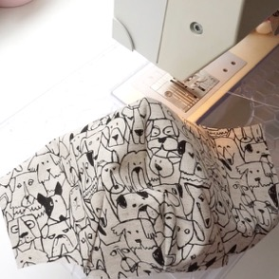
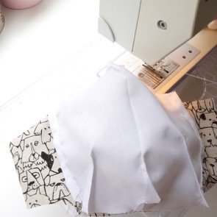 | 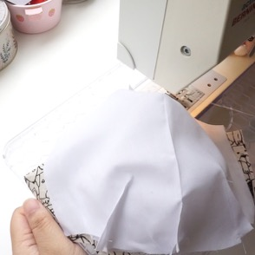
Match all the seams in the centre of the fabric pieces, and pin outwards. Pin one way, then go back and pin the other way. Make sure the darts are not facing the same direction. Otherwise this will become bulky.  Tip: Place the pin 1cm/0.4 inches down from the edge before securing it. This is the seam allowance and will make your seams lines match up and stitching more accurate.  Turn the fabric around and pin the bottom edge of the mask. Pin from centre out, and pin 1cm/0.4 inches down from the edge. | 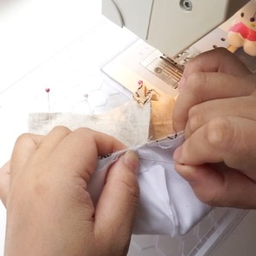
Now we deal with the darts.  We can trim off a little to make sewing a lot easier on the edge. | 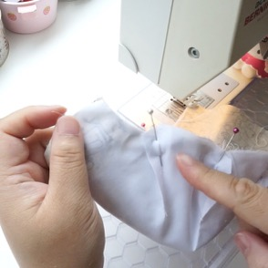
If you have a pin in the dart on the edge, it will get in the way. Place a pin under it before removing. | 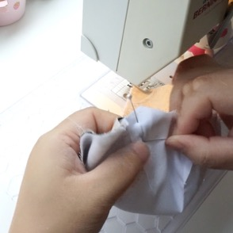
Now you can remove the pin on the edge. | 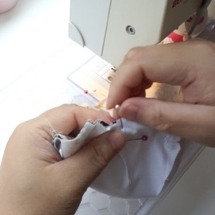
Do the same to the other side of the mask. | 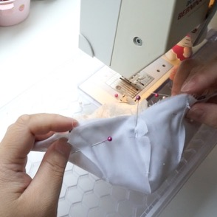
It is now safe to trim off the bit of fabric on the edge of the darts.  Fold the mask in half so that when you cut, everything will be symmetrical. You are only going to cut a bit of the fabric so that the edges on the left and right sides of the dart is joined with a smooth edge. | 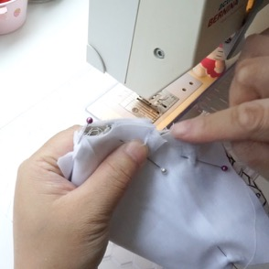
As you can see from the picture, the piece of fabric on the edge of my scissors is not much. | 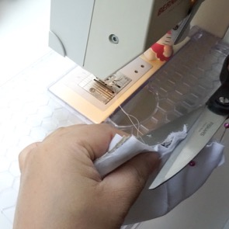
The edge is not totally smooth, but enough to allow you to sew a smooth line.  Now you can sew on both of the pinned edges. | 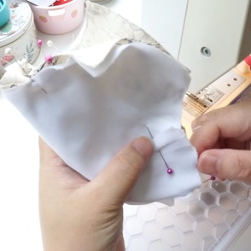
After stitching both edges, you will need to notch/cut/grade/snip the curved edges to help the mask turn and lie flat.  Make these V snips about 1cm/0.4inches apart. Even closer in the very curved areas. | 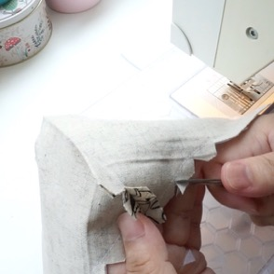
You are ready to bag it out/turn it the right way out.  On the edge, roll the fabric back until you see the shorter fabric on the inside. Pick that and the Main fabric section to turn it the right way out. | 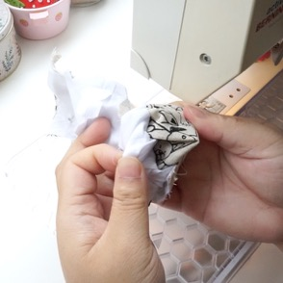
It should look like this.  Get the elastic and seal the ends with a flame. Tie the ends together to form a loop. You should have 2 pieces.  Place one elastic like this onto the edge of the mask. | 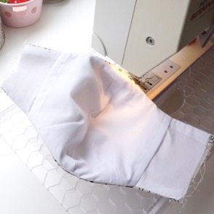
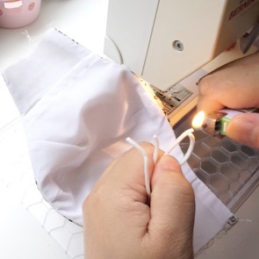 | 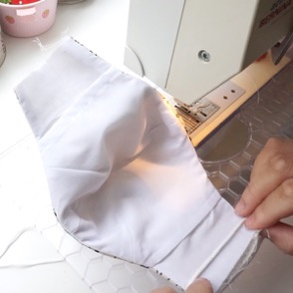
Fold about 5mm/0.19inches over to cover the elastic.  Accuracy is not important here. | 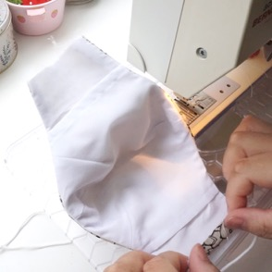
Then roughly fold 1cm/0.4inches over so that you cannot see the raw edges of the fabric. I like to fold so that it butts next to the Filter Lining.  If you have moved/cut the Filter Lining to make it even wider, then I would suggest you to only fold 5mm/0.19inches, then 1cm/0.4inches so it does not affect the width of the mask too greatly. | 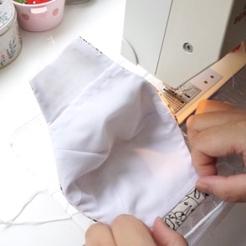
Edge stitch this, careful not to sew into the elastic. | 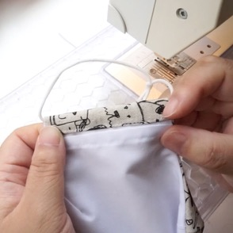
Repeat the elastic process on the other edge.
Adjust the elastic so the knots are hidden in the channel. Careful not to stretch it.
Use a pin, needle or clickers awl to pull out any hidden fabric in the edges. This is usually along the curved edges of the mask.  Use a pin or needle if you don’t have a clickers awl to help you pull out the edges.  You can do this whilst sewing to leave out the ironing process. | 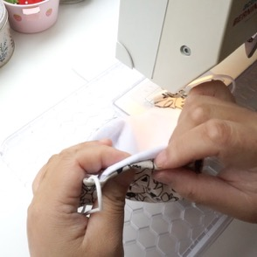
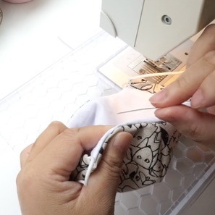 | 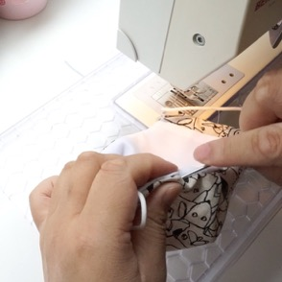
Edge stitch very close to the top and bottom edges of the mask. This will help reinforce it and helps with the structure. | 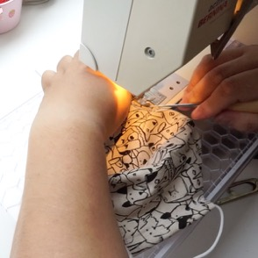
The edge stitching should look like this. | 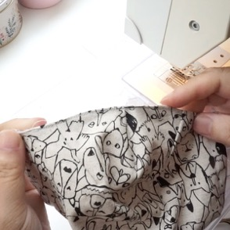
On the top of the mask on the inside, you should see a little gap in the Filter Lining. This is vital for slotting in the nose bar.  You must not sew over this later! | 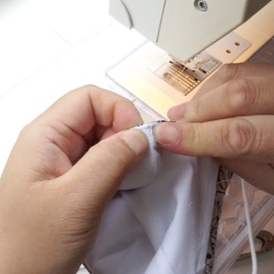
Prepare the wire now if you haven't already done so.  This is optional. If the wire scratches, bend the ends of both sides of the wire inwards.  Then bend the wire again in the centre, inwards.  It will make sliding it in a lot easier. | 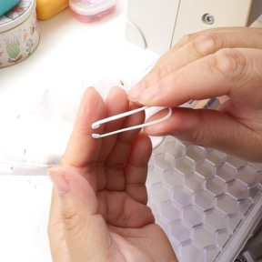
Put the bent nose wire against the top of the mask.  Matching the bend on the wire with the centre of the mask. | 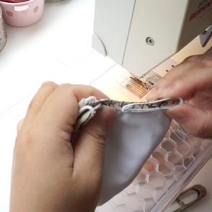
Put 2 pins on either side of the mask where the ends of the wire reach. This can be slightly more.  I like to sew the nose bar channel with the right side of the mask facing up, so that I can see my stitching on the right side.  You may sew on the wrong side up just to keep an eye out for the gap. | 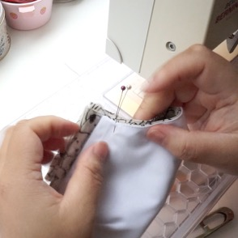
You can sew on the right or wrong side of the mask. Sewing on the wrong side/inside will allow you to see the gap so you can avoid it.
Starting on the left edge of the mask, sew roughly 4-5 stitches downwards. This should be roughly 1cm/0.4inches deep to accommodate for the gap.
Pivot the mask 90 degrees, and using the right edge of the mask as a guide, sew to the next pin.
When you reach the next pin, stop. Pivot 90 degrees again and complete the stitching.
The stitching should look like the picture.
Fold the mask backwards with wrong side out, slide in the nose wire by slotting both ends into the left and right side of the channel. | 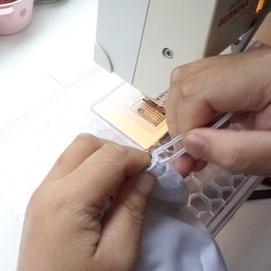
Push in the remaining wire.  If you haven’t already inserted your elastic, do it now.  Complete! | 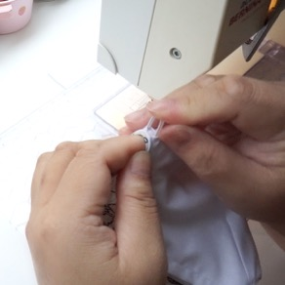
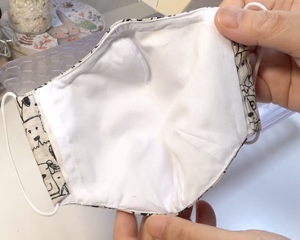 | 