Download the pattern from Shanniemakes.com. You will need the Basic 1 Piece Mask pattern. The pattern will give 2 filter lining options.
- Seam Allowance is 1cm or 0.4inches, 3/8inch unless stated.
- Edge stitching is stitching close to the edge/folded edge. Usually 1-2mm (0.07 inches, 5/64 inch) away from the edge.
- Filter Lining (Also known as the Filter Slot/Filter Lining Slot).

Mask with 2 Filter Options: This mask is based on the Duckbill Style Face Mask. The fit is almost the same, but with minor tweaks. The edges do not use binding and it has an optional nose bar slot. | 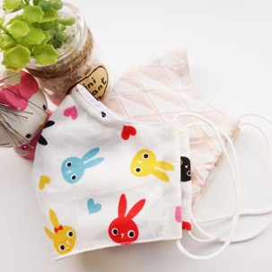
You have the option to shorten the right edge of the Filter Lining pattern.
By shortening it, you will make it wider to allow the easy insertion of a filter.
Cut off anything from 1-4cm/0.4-1.57inches is sufficient amount.
Don't forget you will lose another 1cm/0.4inches at the end when making the edges neat.

Cut out the fabric pieces required:  Main fabric cut x2  Lining cut x2  Filter Lining x2  If you stack the Main fabric and the Lining fabric, you can cut out both layers together to save time. Make sure the folded edge is right on top of each other and aligned. Fold all fabrics with the right side on the inside. Only have the fabric facing out to check on the print placement. | 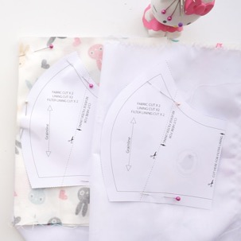
Be aware of your fabric print. You may need to cut it on the weft grain. Making sure the folded edge and the raw edges are parallel.  Check your pattern is on grain by using a ruler and measuring it against the folded or the raw edge and comparing it to both ends of the grainline on the pattern. | Pin the main pattern piece onto the fabric, right against the folded edge.  Cut out required fabric pieces.
On the wrong side of each Filter Lining fabric piece, fold the raw edge on the side by 5mm, then 5mm (0.19 inches, 13/64 inch twice). It is not important to be too accurate. You can go over the measurement slightly.  Edge stitch this in place.  Repeat on the other fabric piece, but remember it is in the reverse/opposite side. | 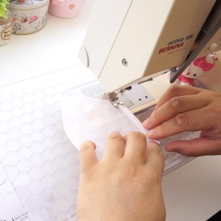
Press with an iron.

Filter Lining (Option 1). Place the right side of the fabric piece touching the right side of the other fabric piece, sew the centre front seam. This is usually the curved seam or could be a dart depending on your pattern, but remember to leave 1cm (0.4 inches, 3/8 inch) gap just before the seam allowance at the centre top edge (Where the nose is) for the nose bar insert. | 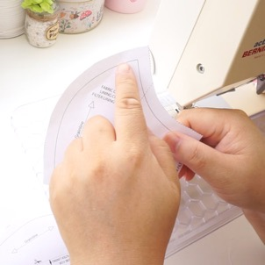
It should look like this. | 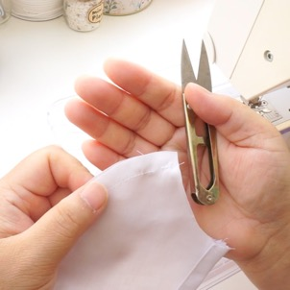
Main Fabric and Lining Fabric. Making sure the 2 Main fabric pieces are right side touching right side, sew the centre front seam. This is usually the curved seam or could be a dart depending on your pattern.  2 Lining fabric pieces, sew as the above.  If your pattern has additional darts, sew these up making sure you are sewing on the wrong side of the fabric. | 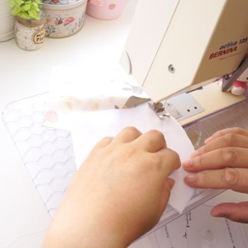
Cut/trim/grade any curved seams on all patterns. Press the seams flat/open/to one side.
Press with an iron.

If you have additional darts on your patterns, especially on the sides, press them to one side with the iron, but not all 2/3 layers on the same side otherwise it will cause bulk.

Place the right side of the Main fabric piece facing up.  Place the Filter Lining slot piece on top, right side touching the right side of the layer underneath.  The Lining goes on last with the wrong side facing up, right side touching the right-side underneath. | 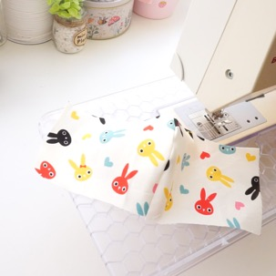
Matching up the seam/dart in the centre, pin in place. Work along the edge pining as you go. Turn it around and pin the other edge. | 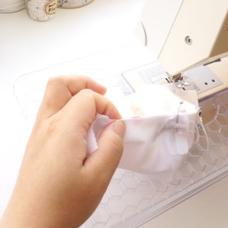
Sew the 2 long edges.

Cut/trim/grade any bulk or curved edges, especially along the top edge of the mask.
Turn the mask the right way out. Turn the side that is between the Main fabric and the Filter Lining slot.

Press with an iron, making sure all edges are not trapped.
Prepare the elastic:
Do this now or at the end if you have a tool to thread the elastic.
Tie the elastic into 2 loops. Seal the ends to stop it from fraying.

Prepare the elastic now if you haven't already done so. Otherwise you can do this at the end if you have a tool to thread the elastic.

Tie the elastic into 2 loops. Seal the ends to stop it from fraying.

With the mask the wrong way up, place one edge of the elastic loop on the edge of the mask. Fold over around 5mm (0.19 inches, 13/64 inch), then 1cm (0.4 inches, 3/8 inch) trapping the elastic inside. Accuracy isn't important here.  I usually just make the 2nd fold sit next to the Filter Lining if I used full width of the pattern.  Edge stitch this in place.  Repeat on the other edge. | 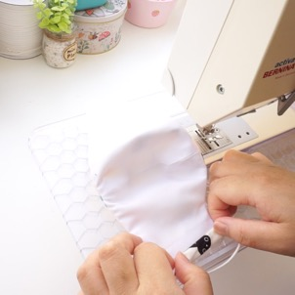
Edge stitch the top and bottom edges of the mask to make it nice and hardwearing. | 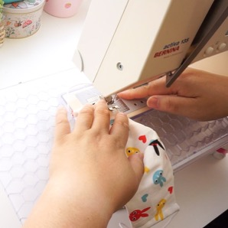
This is optional. If it scratches, bend the ends of both sides of the wire inwards.  Then bend the wire again in the centre, inwards. | 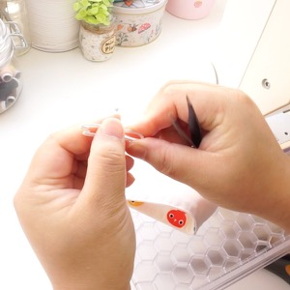
Fold the mask back so that the wrong side is now on the outside.

Put the now bent nose wire against the top of the mask.  Matching the bend on the wire with the centre top of the mask. | 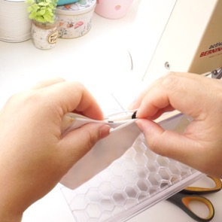
Put 2 pins on either side of the mask where the ends of the wire reach. This can be slightly more.  With the right side of the mask facing up, start sewing from the left pin. | 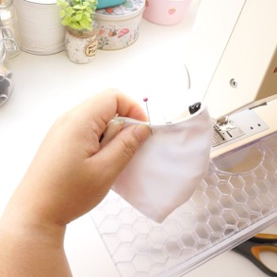
Sew about 3-5 stitches, depending on the width of your nose wire. This must be greater than the nose wire so it can be slotted in later. Stop and turn the mask 90 degrees and continue sewing along the mask using the edge as a guide to keep your stitching parallel to the edge.  You are sewing a channel for the nose wire. Continue until you get to the next pin. Stop. Turn 90 degrees. Finish the stitching. | 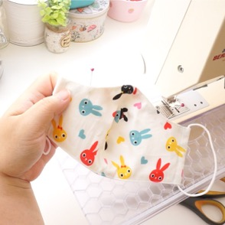
Keeping the mask folded backwards with wrong side out, slide in the nose wire by slotting both ends into the left and right side of the wire slot, then pushing on the bend of the wire.  If you haven’t already inserted your elastic, do it now. | 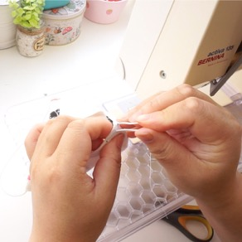
Complete! | 