Download the pattern from Shanniemakes.com. You will need the Basic 1 Piece Mask pattern. The pattern will give 2 filter lining options.
- Seam Allowance is 1cm or 0.4inches, 3/8inch unless stated.
- Edge stitching is stitching close to the edge/folded edge. Usually 1-2mm (0.07 inches, 5/64 inch) away from the edge.
- Filter Lining (Also known as the Filter Slot/Filter Lining Slot).

You have the option to shorten this edge of the Filter Lining pattern.  By shortening it, you will make it wider to allow the easy insertion of a filter.  Cut off anything from 1-4cm/0.4-1.57inches is sufficient amount.  Don't forget you will lose another 1cm/0.4inches at the end when making the edges neat. | 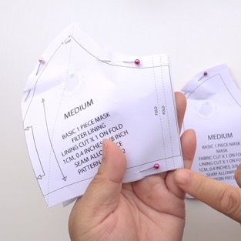
Cut out the fabric pieces required:  Main fabric cut x1 on Fold  Lining cut x1 on Fold  Filter Lining x1 on Fold  If you stack the Main fabric and the Lining fabric, you can cut out both layers together to save time. Make sure the folded edge is right on top of each other and aligned. Fold all fabrics with the right side on the inside. Only have the fabric facing out to check on the print placement. | 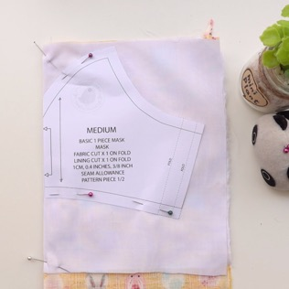
Make sure the fabric is folded on grain. What this means is the raw edge and the folded edge is parallel (Equal distance away from each other).  Be aware of your fabric print. You may need to cut it on the weft grain.  Making sure the folded edge and the raw edges are parallel. | 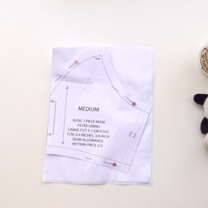
Check your pattern is on grain by using a ruler and measuring it against the folded or the raw edge and comparing it to both ends of the grainline on the pattern.  Pin the main pattern piece onto the fabric, right against the folded edge.  Cut out required fabric pieces. | 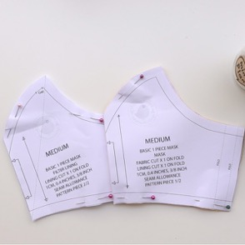
Please note: These fold markings on the side are only guides, you do not have to notch or fold this edge over exactly as illustrated. | 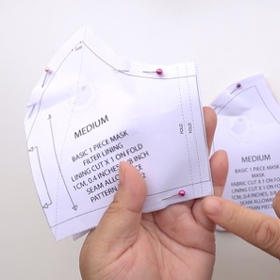
On the Filter Lining pattern, at the very top edge where the nose area is, you need to leave a gap when you are sewing this curve.
Either notch or place a pin here to remind yourself to leave a gap.

On the top edge of all fabric patterns, put a pin or mark this point. | 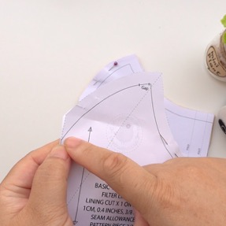
The Filter Lining pattern only requires 1 pin/mark. | 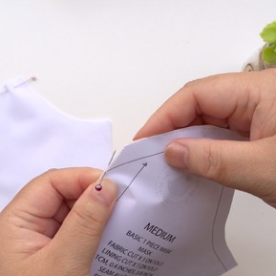
For the Main mask fabric and Lining fabric, which is cut together, you will need to mark the same point on both fabric pieces, or you could pin both sides of the fabrics before pulling away.  If you decide to use the pin option, then the point should look like this on each layer of fabric when pulled apart.  In total you should have 3 fabric pieces that looks like this, each one marked at the point. | 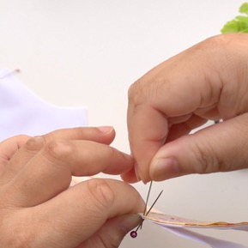
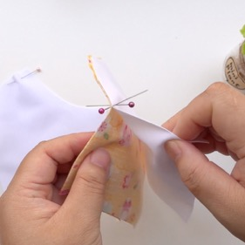 | 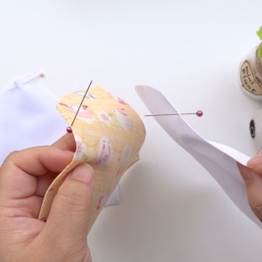
We are going to sew the Filter Lining fabric first.  On the wrong side of the fabric, start sewing from the point at the centre front fold line to the top edge. Remember to leave the gap.  When sewing, you must remember to back stitch at the beginning and end of your sewing. I will not be prompting you to do this. | 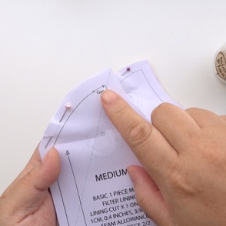
You must back stitch in this area before finishing the dart to ensure it does not become undone later. | 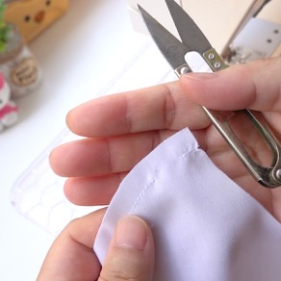
On the side edges of this Filter Lining, with the wrong side facing up, fold over 5mm/0.19inches, then another 5mm/0.19inches. | 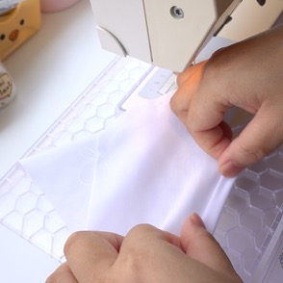
Edge stitch this on the sewing machine.  Repeat on the other edge. | 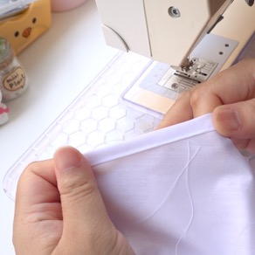
Now repeat all the darts/seams you have done to all the remaining fabric pieces, but leave out the 1cm/0.4inch gap step.  The gap is only required on the Filter Lining pattern. | 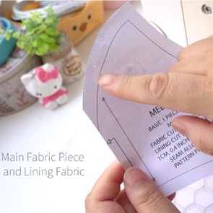
 | 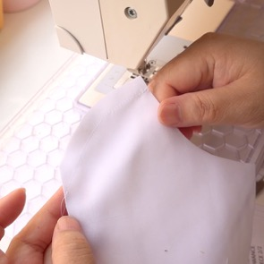
Time to notch the curved edges. This will ensure the seams will lie open and flat when pressed.
Lining: Snip along the seam using diagonal cuts. Careful not to cut into the stitch line.
On the final cut, closest to the point, cut close to the stitch line. This will allow the point to lie flat on either side of the mask when ironed.

Turn it over and snip the remaining notches until you have several V roughly 1cm/0.4inches apart.

Open the seam and run your thumbnail over the seam to break the grain. This will help hold the seams apart ready for pressing. | 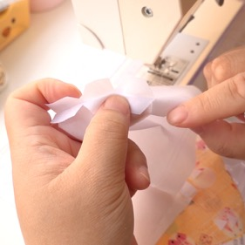
Filter Lining: Here is the gap you need to be aware of. Snip along towards the tip, but not in this gap. | 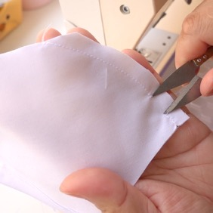
Snip one way first, then the other direction. Roughly 1cm/0.4inch intervals. | 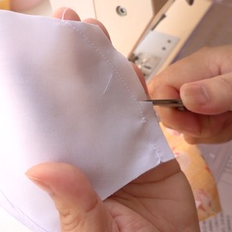
It should look something like this.  Again, open the seam and run your thumbnail along the seam to break the grain to help it to lie open. | 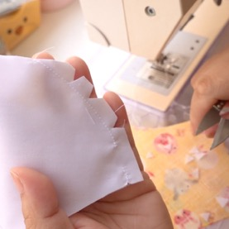
Mask: Repeat the (Lining) steps.  Again, open the seam and run your thumbnail along the seam to break the grain to help it to lie open. | 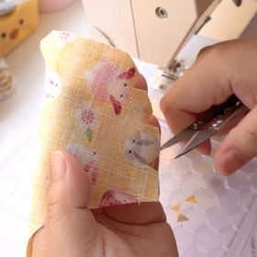
Go to the iron and press all 3 layers of fabric open. Making sure the seams are pressed like this.  The tip can be ironed to either side. | 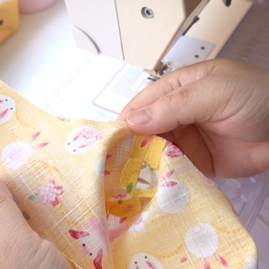
Place the right side of the Main fabric piece facing up.  Place the Filter Lining slot piece on top, wrong side facing up.  The Lining goes on last with the wrong side facing up, right side touching the right-side underneath. | 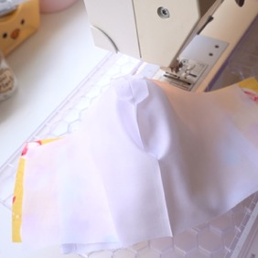
Matching up the seam/dart on the top edge. Start in the centre, pin in place. Work along the edge pinning as you go. Turn it around and pin the bottom edge.  Tip: Put the first pin about 1cm/0.4inch in from the edge. This is the seam allowance. Sewing over this point helps keep the seams aligned. To the same at the bottom edge. | 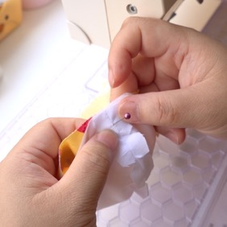
Sew along the 2 long edges. | 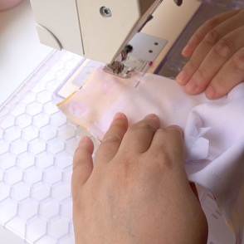
Cut/trim/grade/notch any bulky or curved edges with V shapes at roughly 1cm/0.4inch intervals, especially along the top edge of the mask. | 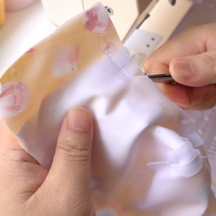
For this mask, the bottom edge isn't required to be notched because there isn't much of a curve.

Turn the mask the right way out.  Turn the section that is between the Main fabric and the Filter Lining slot (Shorter Fabric).  Give the mask a quick press. | 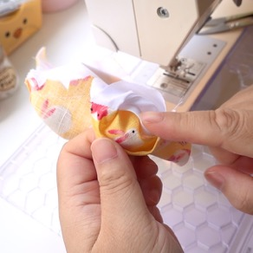
Prepare the elastic now if you haven't already done so. Otherwise you can do this at the end if you have a tool to thread the elastic.  Tie the elastic into 2 loops. Seal the ends to stop it from fraying. | 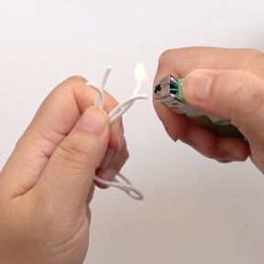
With the mask the wrong side facing up, place one edge of the elastic loop on the edge of the mask. Fold over around 5mm/0.19 inches.  Then 1cm/0.4 inches trapping the elastic inside.  Accuracy isn't important here.  I usually just make the 2nd fold sit next to the Filter Lining slot if I used full width of the pattern. | 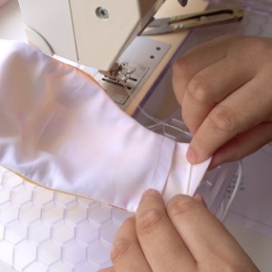
Edge stitch this in place.  Careful not to sew over the elastic.  Repeat the elastic process on the other edge. | 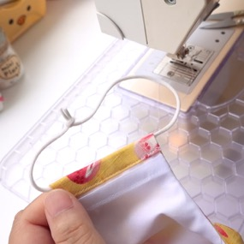
Carefully pull the elastic ends into the channel. Try not to stretch it.  Repeat on the other edge. | 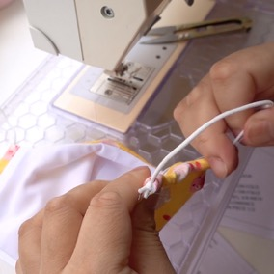
Before you sew the edge stitching, make sure all edges don’t have fabric trapped.

Use a pin or clickers awl to help pull the edges out.
Re-press with the iron.
Tip: If you’ve tried pulling the seam to the edge to be ironed was difficult, you could always use a pin/needle/clickers awl to ease out the seam as you sew the top stitch.

Edge stitch very close to the top and bottom edges of the mask. This will help reinforce it and helps with the structure. | 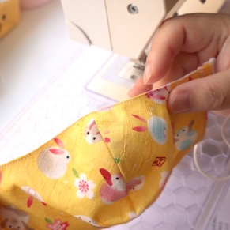
Fold the mask backwards so that the inside is only exposed.  If you done this accurately you should have a 1cm/0.4inch gap to slot your wire in later. | 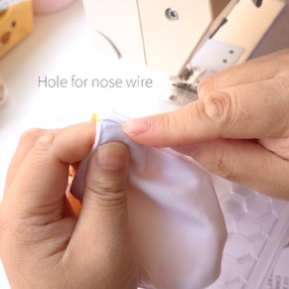
Prepare the wire now if you haven't already done so. This is optional.  If the wire scratches, bend the ends of both sides of the wire inwards.  Then bend the wire again in the centre, inwards.  Put the now bent nose wire against the top of the mask.  Matching the bend on the wire with the centre top of the mask. | 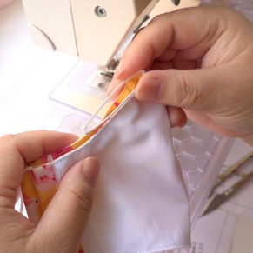
Put 2 pins on either side of the mask where the ends of the wire reach. This can be slightly more.  I like to sew the nose bar channel with the right side of the mask facing up, so that I can see my stitching on the right side.  You may sew on the wrong side up just to keep an eye out for the gap. | 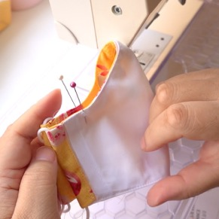
Starting on the left edge of the mask, sew roughly 4-5 stitches. This should be roughly 1cm/0.4inches deep to accommodate for the gap.
Pivot the mask 90 degrees, and using the edge as a guide, sew to the next pin.
When you reach the next pin, stop. Pivot 90 degrees again and complete the stitching.

It should look like this. | 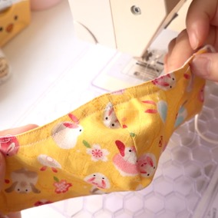
Keeping the mask folded backwards with wrong side out, slide in the nose wire by slotting both ends into the left and right side of the channel, then pushing on the bend of the wire.  If you haven’t already inserted your elastic, do it now. | 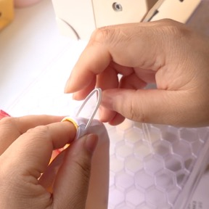
Complete! | 