Download the pattern from Shanniemakes.com. The pattern you will need will be the Basic 1 Piece Mask. The pattern will give 2 filter lining options.
- Seam Allowance is 1cm or 0.4inches, 3/8inch unless stated.
- Edge stitching is stitching close to the edge/folded edge. Usually 1-2mm (0.07inches, 5/64 inch) away from the edge.
- Filter Lining (Also known as the Filter Slot/Filter Lining Slot).
You need to first prepare the Filter Lining by cutting the diagonal dash line.  Do not discard this piece because it will be the guide for the gap later. | 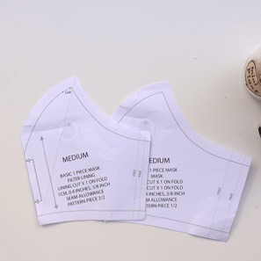
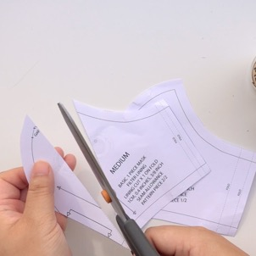 | 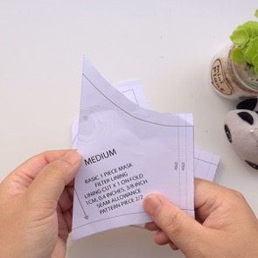
Important: Please note, when you eventually put the fabric patterns together to sew, you need to align it like this on the bottom left picture and never like on the right picture. | If you look, the pattern fits perfectly on the left picture. On the right picture, the right edge is moved to match the edge of the pattern, but the rest of the pattern has shifted out of place.
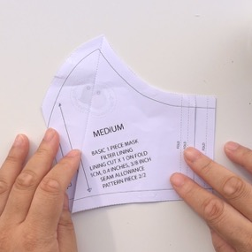  CORRECT POSITION | 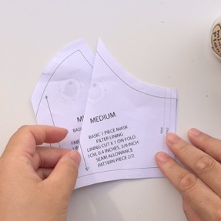  WRONG POSITION
Cut out the fabric pieces required:  Main fabric cut x1 on Fold  Lining cut x1 on Fold  Filter Lining cut x2 Pieces  If you stack the fabrics together you can cut out both layers together to save time. Make sure the folded edge is right on top of each other and aligned. Fold all fabrics with the right side on the inside. Only have the fabric facing out to check on the print placement. | Make sure the fabric is folded on grain. What this means is the raw edge and the folded edge is parallel (Equal distance away from each other).  Be aware of your fabric print. You may need to cut it on the weft grain.  Making sure the folded edge and the raw edges are parallel.
Check your pattern is on grain by using a ruler and measuring it against the folded or the raw edge and comparing it to both ends of the grainline on the pattern.  Pin the main pattern piece onto the fabric, right against the folded edge.  Cut out required fabric pieces. | 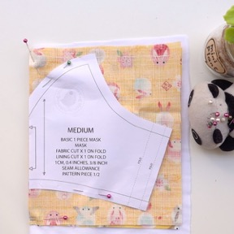
For the Filter Lining, if you fold the fabric and place the pattern slightly away from the edge, you will cut 2 at the same time.  Make sure it is cut on grain. | 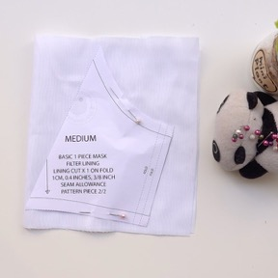
Once the fabric pieces are cut out, place the patterns on top each other like this. | 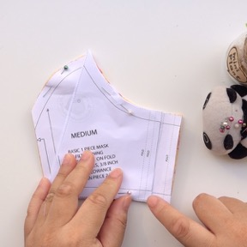
On the top edge cut a small notch through all layers. I used the inside line as a guide.  This should be a tiny cut and never deep! | 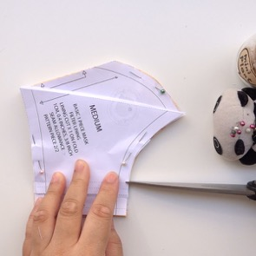
Do this to the bottom edge too. Cut through all layers.  This should be a tiny cut and never deep! | 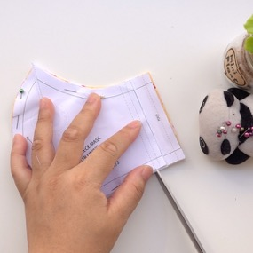
Main mask, on the centre front point of both fabric pieces, put a pin or mark this point.  You could always use a piece of chalk or pencil to make the markings. | 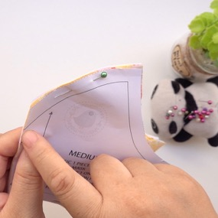
Main mask pattern has 2 layers of fabric, we need to put one pin in through this direction. Can be done to both layers. | 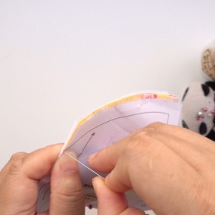
Then another pin in through the back. Can be done to 2 layers. | 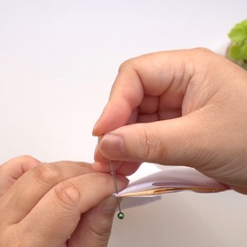
When you pull apart, both pieces are marked. | 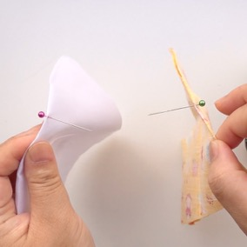
Because we are making the Reverse Filter Lining, the gap for the nose bar channel has to be done on the Lining layer. This is usually done on the Filter Lining layer if we were making it the Conventional method.  Either get the piece that was cut off to help you mark this gap area back in, or just put a pin in roughly 1cm/0.4inches away from the end of the curve (Seam Allowance). The gap should be roughly 1cm wide. | 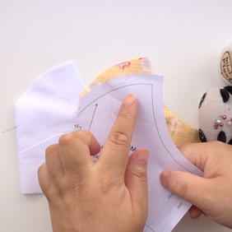
Placing a pin on the Lining layer will help remind you later on where to leave the gap when you start sewing.

We are now going to sew this edge of the Filter Lining. | 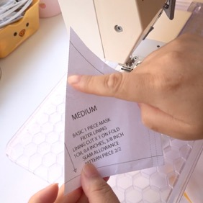
Open it out like this so it is opposite each other. Wrong sides facing up. | 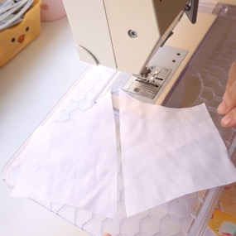
Fold over 5mm/0.19inches twice so that the raw edge is tucked under.  Put a pin in to hold it in place.  By preparing it this way you are bound to get it right. | 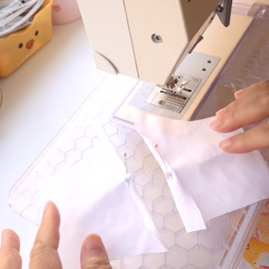
Sew this down close to the edge.  Do it to both fabric pieces.  Don't worry if it twists. Pressing with an iron will help it lie flat later. | 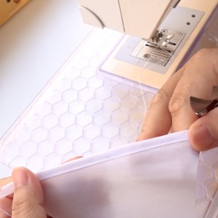
Snip off any excess fabric at both ends of each Filter Lining. | 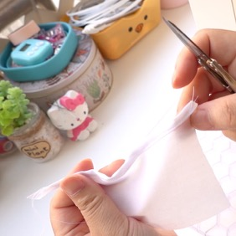
We are now going to sew the curved edges on the Main/Lining fabric pieces.

Start off with sewing the Main mask fabric. Put the edge with the pin in into the sewing machine.  Lower the needle down into the point, then the presser foot.  Sew a bit until you can gauge using the seam allowance.  Complete the seam. | 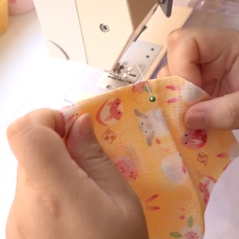
The seam should be even. | 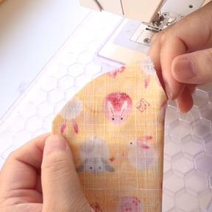
Next sew the Lining.  Remember to leave a gap of 1cm/0.4inches, about 1cm/0.4inches away from the edge.  Back stitching is very important to ensure the stitching does not come undone. | 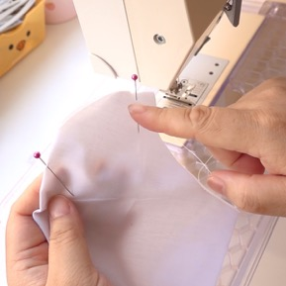
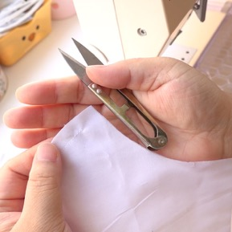 | 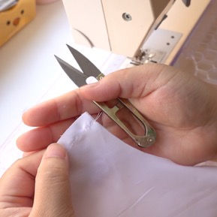
Time to notch the curved edges. This will ensure the seams will lie open and flat when pressed.  Main fabric: Snip along the seam using diagonal cuts. Careful not to cut into the stitch line.  On the final cut near the tip/point (Centre Front), snip it slightly close to the stitch line. This will allow the tip to lie on the side when ironed. | 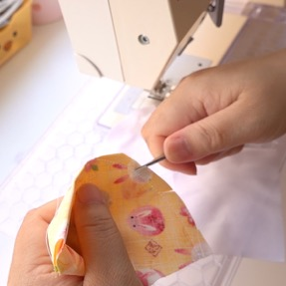
As you can see here, the tip can be pushed to one side.  You can run your thumbnail along the open seam to help break the grain of the fabric to help the seam lie open before pressing with the pressed/ironed. | 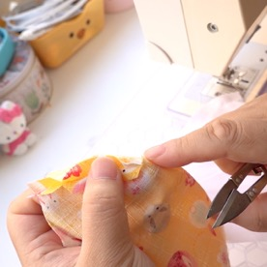
Do the same to the Lining piece.  Snip towards the tip/point. No need to snip at the gap.  Final snip, cut it close to the stitch line, then go back to snip out the V shape.  Run your thumbnail along the seam to break the grain to help the seam allowance to lie open. | 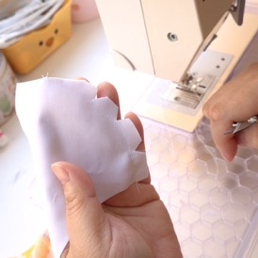
Press all seams open with an iron. | 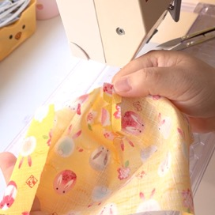
Main layer right side facing up. | 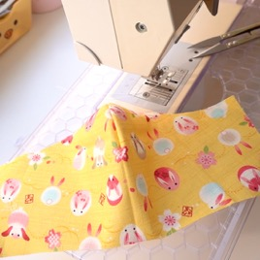
Filter Lining pieces go on next, but making sure the wrong side is facing upwards. You can tell by the way the edges are folded. | 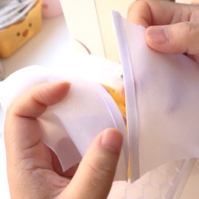
Place it on top of the Main mask on either side.  Locate the notches and match up with the Main mask fabric. There should be one on the top and one at the bottom. Same to the other side.  Once you are matched up the notches, place a pin to hold it in place. Do this to the other Filter Lining piece. | 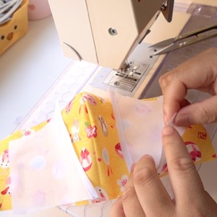
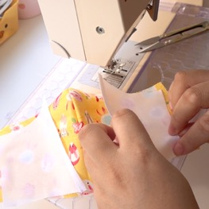 | 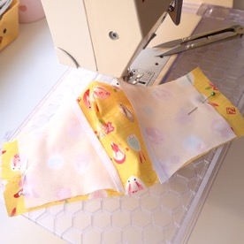
Finally place the Lining layer on top. Wrong side facing up.  Make sure you match the correct edges together. | 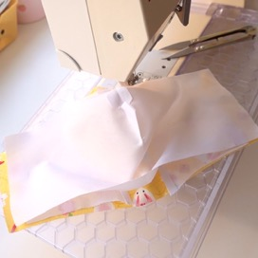
At the centre front, put a pin in roughly 1cm/0.4inches down from the edge, then secure the pin. | 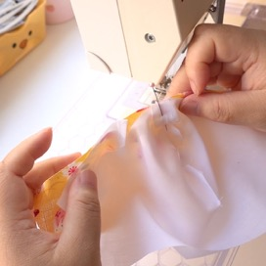
Start pinning along the top edge.
Pin along the bottom edge starting from the centre going outwards.

Sew along the top and bottom edges of the mask. | 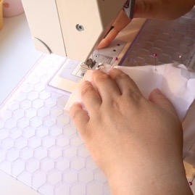
Cut/trim/grade/notch any bulky or curved edges with V shapes at roughly 1cm/0.4inch intervals. | 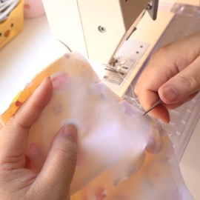
It is very important to do this to the top edge of the mask because of the curved edge. | 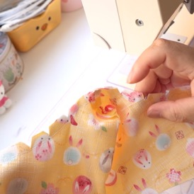
Turn the mask the right way out.  Turn the side that is between the Main fabric and the Filter Lining. | 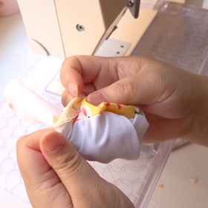
Before you press with an iron, make sure the edges are pulled out and not tucked in.
The shape will be affected if this is not done properly.

If you do not have a clickers awl to use, use a pin or needle to help bring the edges out.
Now give the mask a good press with the iron.

If you haven't already prepared the elastic and nose bar, do it now. Otherwise you can do this at the end if you have a tool to thread the elastic.  Tie the elastic into 2 loops. Seal the ends to stop it from fraying. | 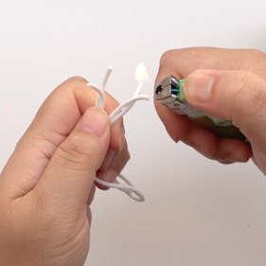
Cut the nose bar to size if you are using any.  If the end of the wire scratches, it is best to bend the ends of both sides of the wire inwards.  Prepare it like this for easy insertion. | 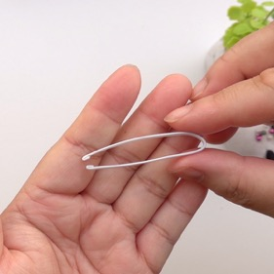
With the mask the wrong side facing up, place one edge of the elastic loop on the edge of the mask.  Fold over around 5mm/0.19inches trapping the elastic inside.  Then fold 1cm/0.4inches. This second fold should cover over the raw edges of the Filter Lining.  Accuracy isn't important here. | 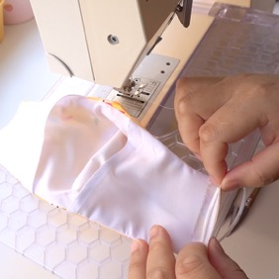
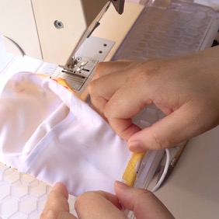 | 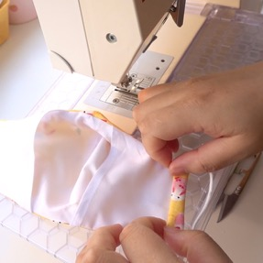
Edge stitch along this edge to secure the elastic channel.  Careful not to sew over the elastic.  Tuck in the end of the elastic. Careful not to over stretch the elastic.  Repeat on the other edge of the mask. | 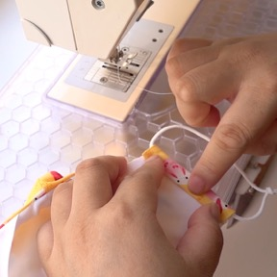
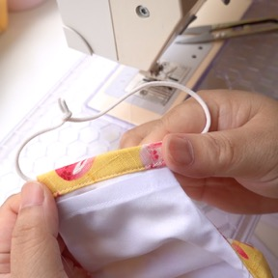
Edge stitch very close to the top and bottom edges of the mask.  Avoid sewing over the elastic. | 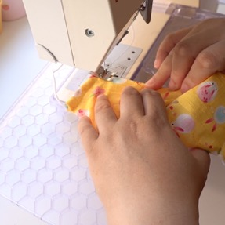
This will help reinforce it and give it structure. | 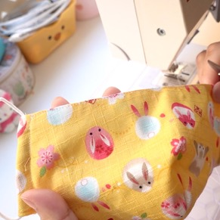
Fold the mask backwards so that the inside is only exposed.  If you done this accurately you should have a 1cm gap to slot your wire in later.  Prepare the wire now if you haven't already done so. This is optional. If the wire scratches, bend the ends of both sides of the wire inwards.  Then bend the wire again in the centre, inwards. | 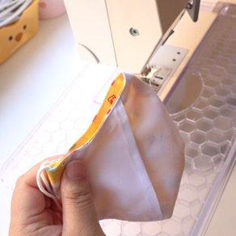
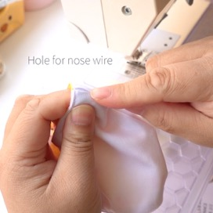 | 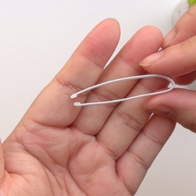
Put the now bent nose wire against the top of the mask.  Matching the bend on the wire with the centre top of the mask. | 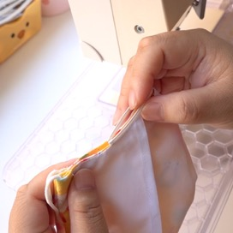
Put 2 pins on either side of the mask where the ends of the wire reach. This can be slightly more.  I like to sew the nose bar channel with the right side of the mask facing up, so that I can see my stitching on the right side. | 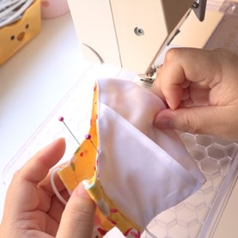
Starting on the left edge of the mask, sew roughly 4-5 stitches. This should be roughly 1cm deep to accommodate for the gap.  Pivot the mask 90 degrees, and using the edge as a guide, sew to the next pin.  When you reach the next pin, stop. Pivot 90 degrees again and complete the stitching. | 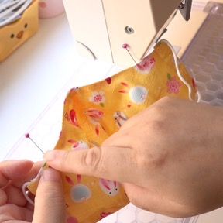
 | 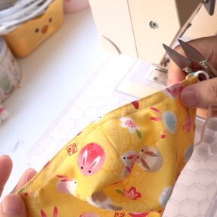
Keeping the mask folded backwards with wrong side facing out, slide in the nose wire by slotting both ends into the left and right side of the channel, then pushing on the bend of the wire.  If you haven’t already inserted your elastic, do it now.  Complete! | 