Download the pattern from Shanniemakes.com. The pattern you will need will be the Cover Mask. The pattern will give 2 filter lining options.
- Seam Allowance is 1cm or 0.4inches, 3/8inch unless stated.
- Edge stitching is stitching close to the edge/folded edge. Usually 1-2mm (0.07inches, 5/64 inch) away from the edge.
- Filter Lining (Also known as the Filter Slot/Filter Lining Slot).
You need to first prepare the Filter Lining by cutting the diagonal dash line. | 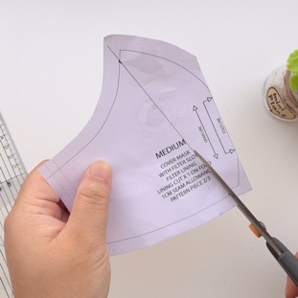
Do not discard this piece because it will be the guide for the gap later. | 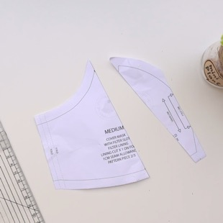
Important: Please note, when you eventually put the fabric patterns together to sew, you need to align it like this on the bottom left picture and never like on the right picture. | If you look, the pattern fits perfectly on the left picture. On the right picture, the right edge is moved to match the edge of the pattern, but the rest of the pattern has shifted out of place.
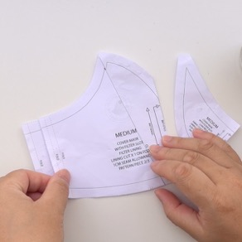  CORRECT POSITION | 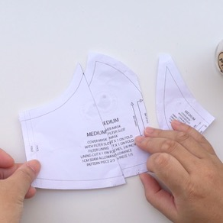  WRONG POSITION
Cut out the fabric pieces required:  Main fabric cut x1 on Fold  Lining cut x1 on Fold  If you stack the fabrics together you can cut out both layers together to save time. Make sure the folded edge is right on top of each other and aligned. Fold all fabrics with the right side on the inside. Only have the fabric facing out to check on the print placement. | Make sure the fabric is folded on grain. What this means is the raw edge and the folded edge is parallel (Equal distance away from each other).  Be aware of your fabric print. You may need to cut it on the weft grain.  Making sure the folded edge and the raw edges are parallel.
Check your pattern is on grain by using a ruler and measuring it against the folded or the raw edge and comparing it to both ends of the grainline on the pattern.  Pin the main pattern piece onto the fabric, right against the folded edge.  Cut out required fabric pieces. | 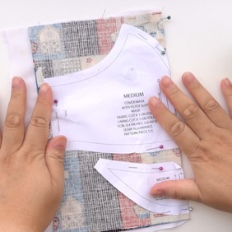
Filter Lining x2  If you fold the fabric and place the pattern slightly away from the edge, you will cut 2 at the same time.  Make sure it is cut on grain. | 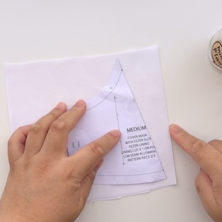
Once the fabric pieces are cut out, place the patterns on top each other like this. | 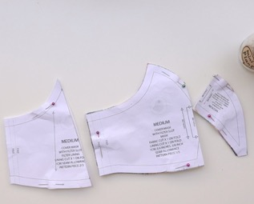
On the top edge cut a small notch through all layers. I used the inside line as a guide.  Do this to the bottom edge too. Cut through all layers.  This should be a tiny cut and never deep! | 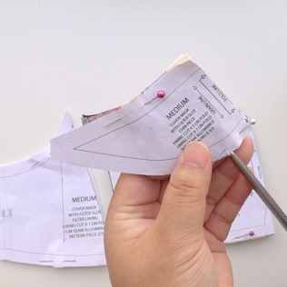
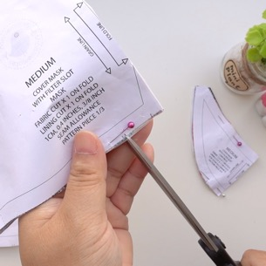 | 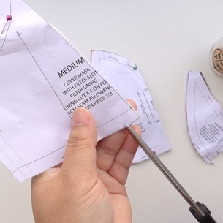
Place the Filter Lining on top of the Main mask pattern like this.  This is the proper position. | 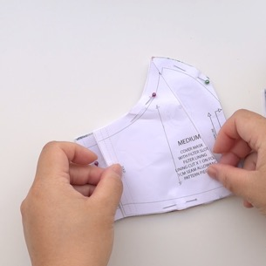
The left edge sits next to the inside fold line on the pattern underneath. | 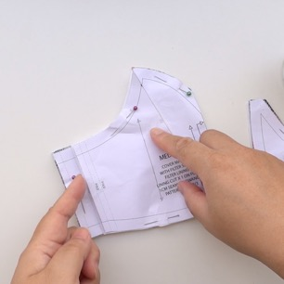
Carefully hold the patterns together and make a little snip on the inside fold line, on all layers. | 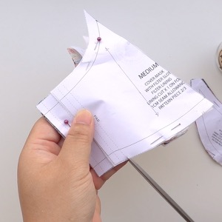
Do the same on the top edge. | 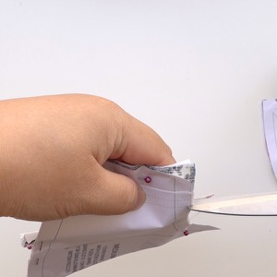
As long as you snipped the top and bottom edges with a notch, you should be fine to put the mask together later. | 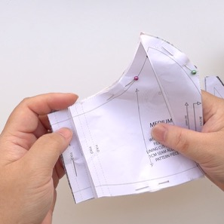
Time to sew the Chin Piece.

Open the fabric out. Placing the right sides touching the right sides. | 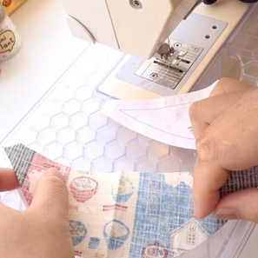
You are going to sew the top edge.
Now either cut/snip/grade/notch the curved seam on the just sewn top edge.  Snip in one direction. | 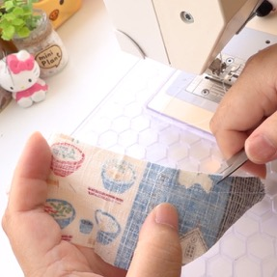
Then snip the other direction will make your work a lot easier.  Snip until you have cut out V notches about 1cm/0.4inches intervals along this edge. This will help the fabric to fold over. | 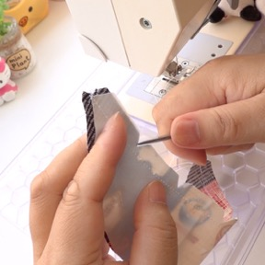
Open the fabric out.  Make sure the seam allowance is on the left side, under the Lining fabric. (Under the left side fabric which is the white side under my hand) | 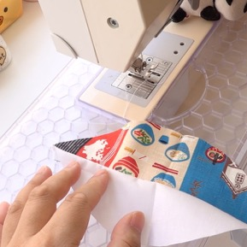
You are going to edge stitch on the Lining side, really close to the seam line.  Hold the fabrics apart when sewing. This will help stop any fabric being caught underneath. | 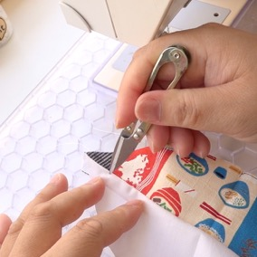
The edge stitch should look like this. | 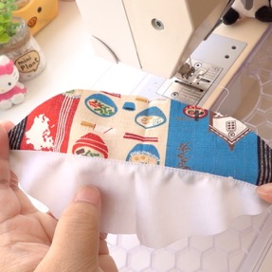
Fold it back into shape. | 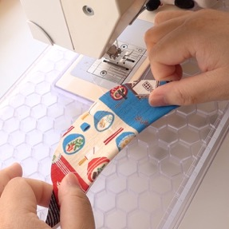
You should roll it so that you see a tiny bit of the Main fabric showing on the edge. | 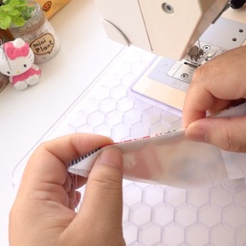
We are now going to sew this edge of the Filter Lining.

Open it out like this so it is opposite each other. Wrong sides facing up. | 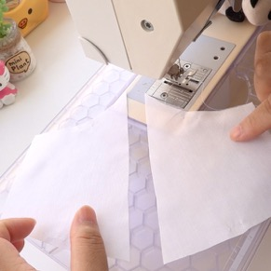
Fold over 5mm/0.19inches twice so that the raw edge is tucked under.  Put a pin in to hold it in place.  By preparing it this way you are bound to get it right. | 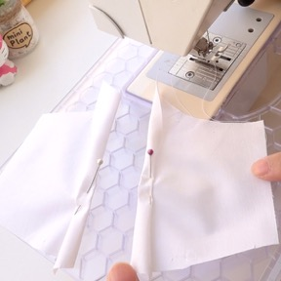
Sew this down close to the edge.  Do it to both fabric pieces.  Snip off any excess fabric at both ends of each Filter Lining. | 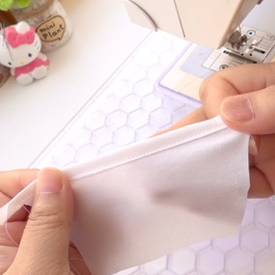
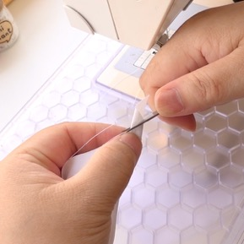 | 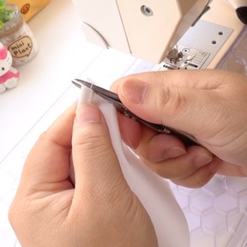
Don't worry if it twists. Pressing with an iron will help it lie flat later. | 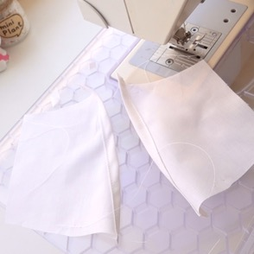
You can use tailors chalk or a pencil to put in the markings, but I find it much easier to use pins.
Place a pin into the top point of the dart/seam on the Fold of the fabric. This can be through both pieces of fabric.
Place a pin into the bottom point of the dart/seam on the Fold of the fabric. This can be through both pieces of fabric. | 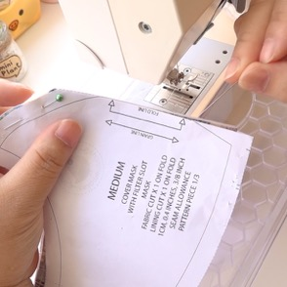
Should look like this. | 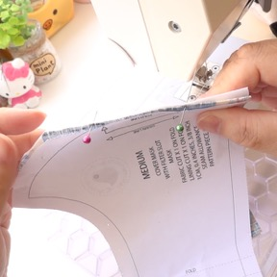
Now turn the fabric over and place 2 pins into the same points where the pins came through. | 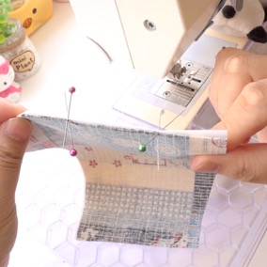
Pull the 2 fabric pieces apart. Both fabrics are now marked. | 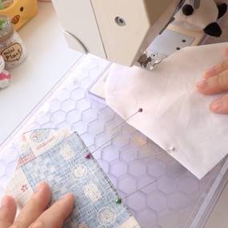
At the top point. Sew to the edge.  Make sure the dart/seam is sewn evenly.  (See below)  Sew the bottom dart. From the point to the first notch closest to the folded edge. | 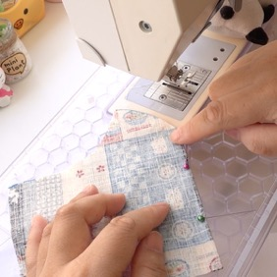
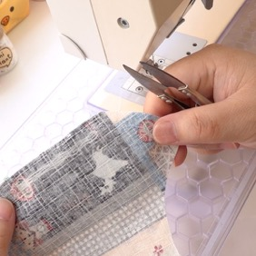 | 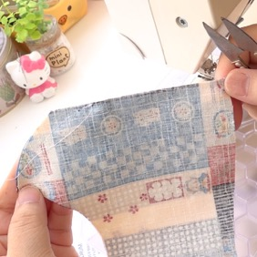
Next we sew the dart/seam on the Lining.  Please note: We usually leave the gap on the Filter Lining, but because we are making the Reverse Filter Lining we have to leave a gap for the nose bar to slot in on the Lining this time.  You can place a pin here to remind yourself to leave a gap of 1cm/0.4inches. | 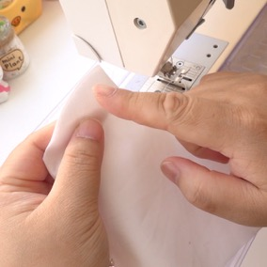
The gap should be indicated on the up-to-date pattern. The position is roughly here, 1cm/0.4inches away from the edge.  Sew from the top point to the top edge of the mask. Back stitching is vital here.  Leave a 1cm/0.4inch gap.  Back stitch and complete the seam. | 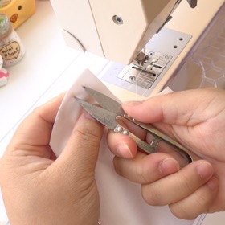
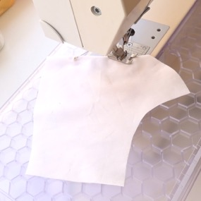 | 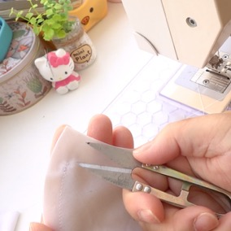
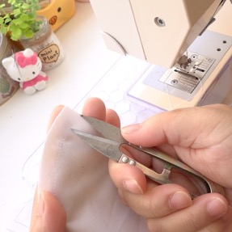 | 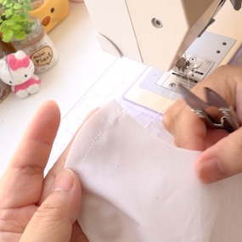
Complete the bottom dart by sewing the bottom point to the first notch next to the folded edge. | 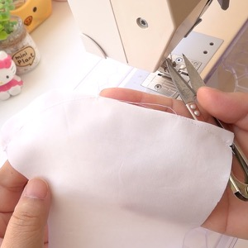
You should have the Main fabric with the top dart/seam sewn fully.  The Lining fabric is like the Main fabric, but with a little gap. | 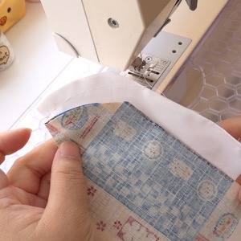
We now have to either cut/snip/grade/notch along the curved edges. | 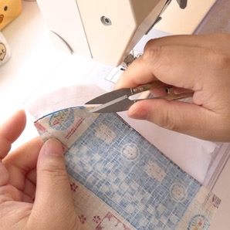
Make the cut closest to the point a little deeper to allow the point to lie on one side when pressed with an iron.  Careful not to cut too close to the stitch line. | 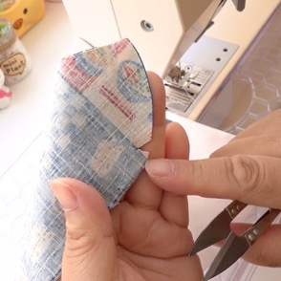
Make V shape cuts roughly 1cm/0.4inch intervals. | 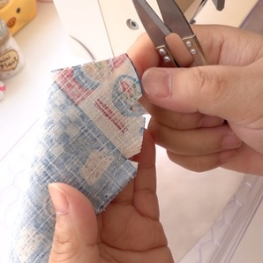
As you can see the tip lies down easily. | 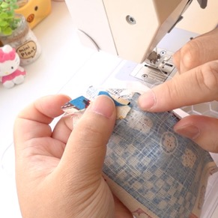
Repeat the cut/snip/grade/notch process on the Lining fabric.  Avoid snipping into the gap. | 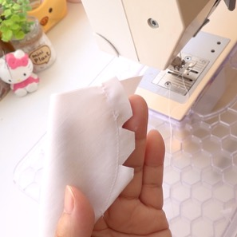
Press your fabric pieces and open any seams when pressing.  Time to assemble. | 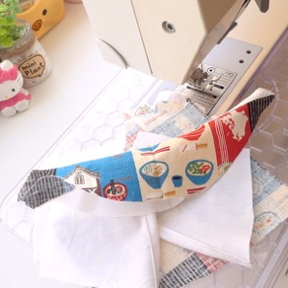
Main fabric layer with right side facing up. | 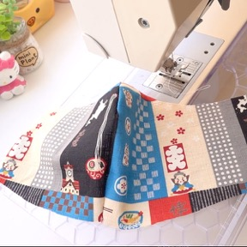
Chin Piece fold in half.  On the bottom right corner………  Make a little snip diagonally. Otherwise this could be a small notch. It is much easier to see when it is cut at an angle. | 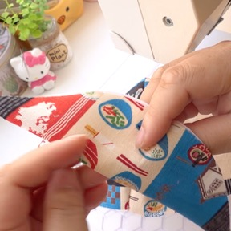
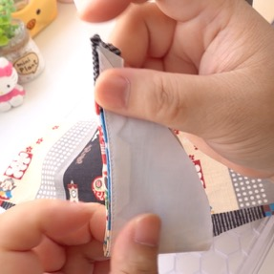 | 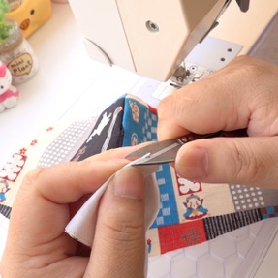
Top edge cut off any excess fabric. | 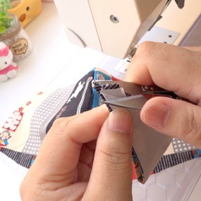
When you open it back up you should see a small triangle cut out. | 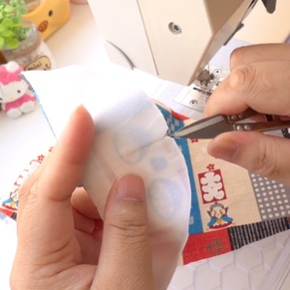
Chin Piece with wrong side facing up. Looks like a smile. | 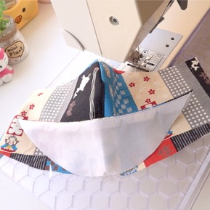
Filter Lining wrong sides facing up. Place it either side of the mask.  Make sure you place it so the notches match up at the top and bottom edges.  This was reminded at the beginning marked in Green text. | 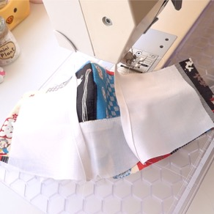
Lining on top with wrong side facing up. | 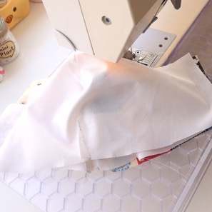
Top edge, match up the seams in the centre.  Place the pin 1cm/0.4inches down from the edge. This will make the seams match up accurately.  Start pinning outwards.  Make sure the Filter Lining does not shift out of place. The notches help you match up.  Go back into the centre and pin out the other direction. | 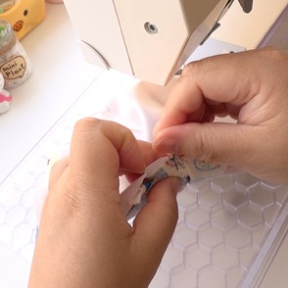
Go back into the centre and pin out the other direction.
Take your time when pinning the bottom edge. It is hard to pin a curved edge to a straight edge.
You can baste the layers first if you are more advance.
You are ready to sew once both edges are pinned.
1cm/0.4inch seam allowance, sew both edges.
After you have sewn the edge, either cut/snip/grade/notch both edges.
Snip out V notches at roughly 1cm/0.4inch intervals. Especially paying special attention the curved edges. It will make turning over and making the mask lie flat a breeze.
Do this to the other edge. | 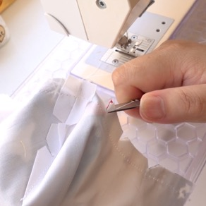
Turn the mask the right way out.  Choose the section between the Main fabric and the short Filter Lining.  Give it a press with an iron. | 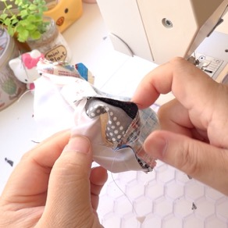
If you haven't already prepared the elastic and nose bar, do it now. Otherwise you can do this at the end if you have a tool to thread the elastic.  Tie the elastic into 2 loops. Seal the ends to stop it from fraying. | 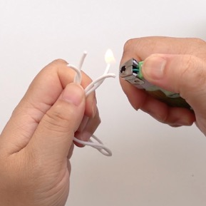
With the mask the wrong side facing up, place one edge of the elastic loop on the edge of the mask. | 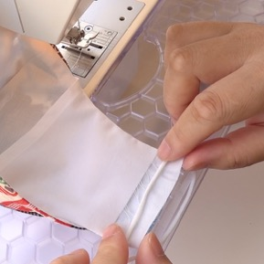
Fold over around 5mm/0.19inches trapping the elastic inside. | 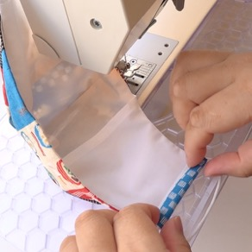
Then fold 1cm/0.4inches. This second fold should cover over the raw edges of the Filter Lining.  Accuracy isn't important here. | 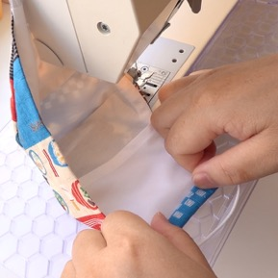
Adjust the elastic to the edge so it doesn’t get caught in the edge stitch. | 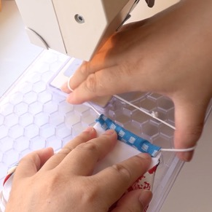
Edge stitch along this edge to secure the elastic channel.  Careful not to sew over the elastic. | 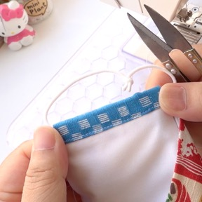
Tuck in the end of the elastic. Careful not to over stretch the elastic.  Repeat on the other edge of the mask. | 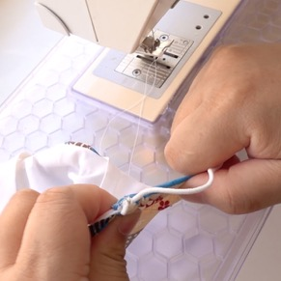
Edge stitch very close to the top and bottom edges of the mask. This will help reinforce it and helps with the structure.  Use a pin/needle/clickers awl to help ease out any fabric tucked inside on the seam edges. You can ease as you sew if it helps.  Avoid sewing over the elastic on the edges. | 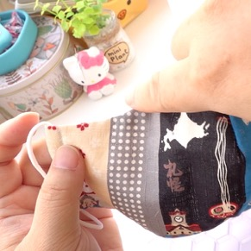
This will help reinforce it and give it structure. | 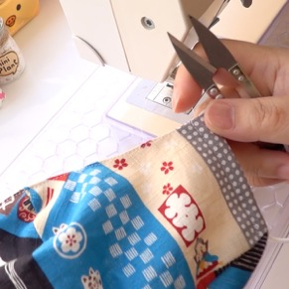
It is optional to edge stitch at the bottom edge.  If you do want to sew it, it will be on this side of the mask. | 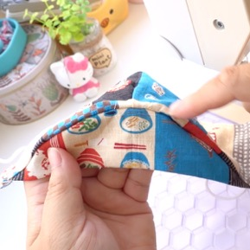
Prepare the wire now if you haven't already done so. This is optional. If the end of the wire scratches, it is best to bend the ends of both sides of the wire inwards.  Then bend the wire again in the centre, inwards.  Prepare it like this for easy insertion. | 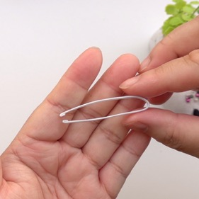
Fold the mask backwards so that the inside is only exposed.
If you done this accurately you should have a 1cm/0.4inch gap to slot your wire in later.

Put the now bent nose wire against the top of the mask.  Matching the bend on the wire with the centre top of the mask. | 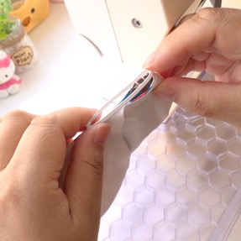
Put 2 pins on either side of the mask where the ends of the wire reach. This can be slightly more.  I like to sew the nose bar channel with the right side of the mask facing up, so that I can see my stitching on the right side. | 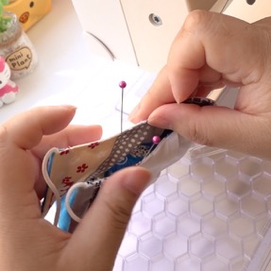
Starting on the left edge of the mask, sew roughly 4-5 stitches. This should be roughly 1cm deep to accommodate for the gap.  Pivot the mask 90 degrees, and using the edge as a guide, sew to the next pin.  When you reach the next pin, stop. Pivot 90 degrees again and complete the stitching. | 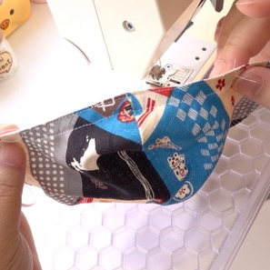
Keeping the mask folded backwards with wrong side facing out, slide in the nose wire by slotting both ends into the left and right side of the channel, then pushing on the bend of the wire.

If you haven’t already inserted your elastic, do it now.  Complete! | 